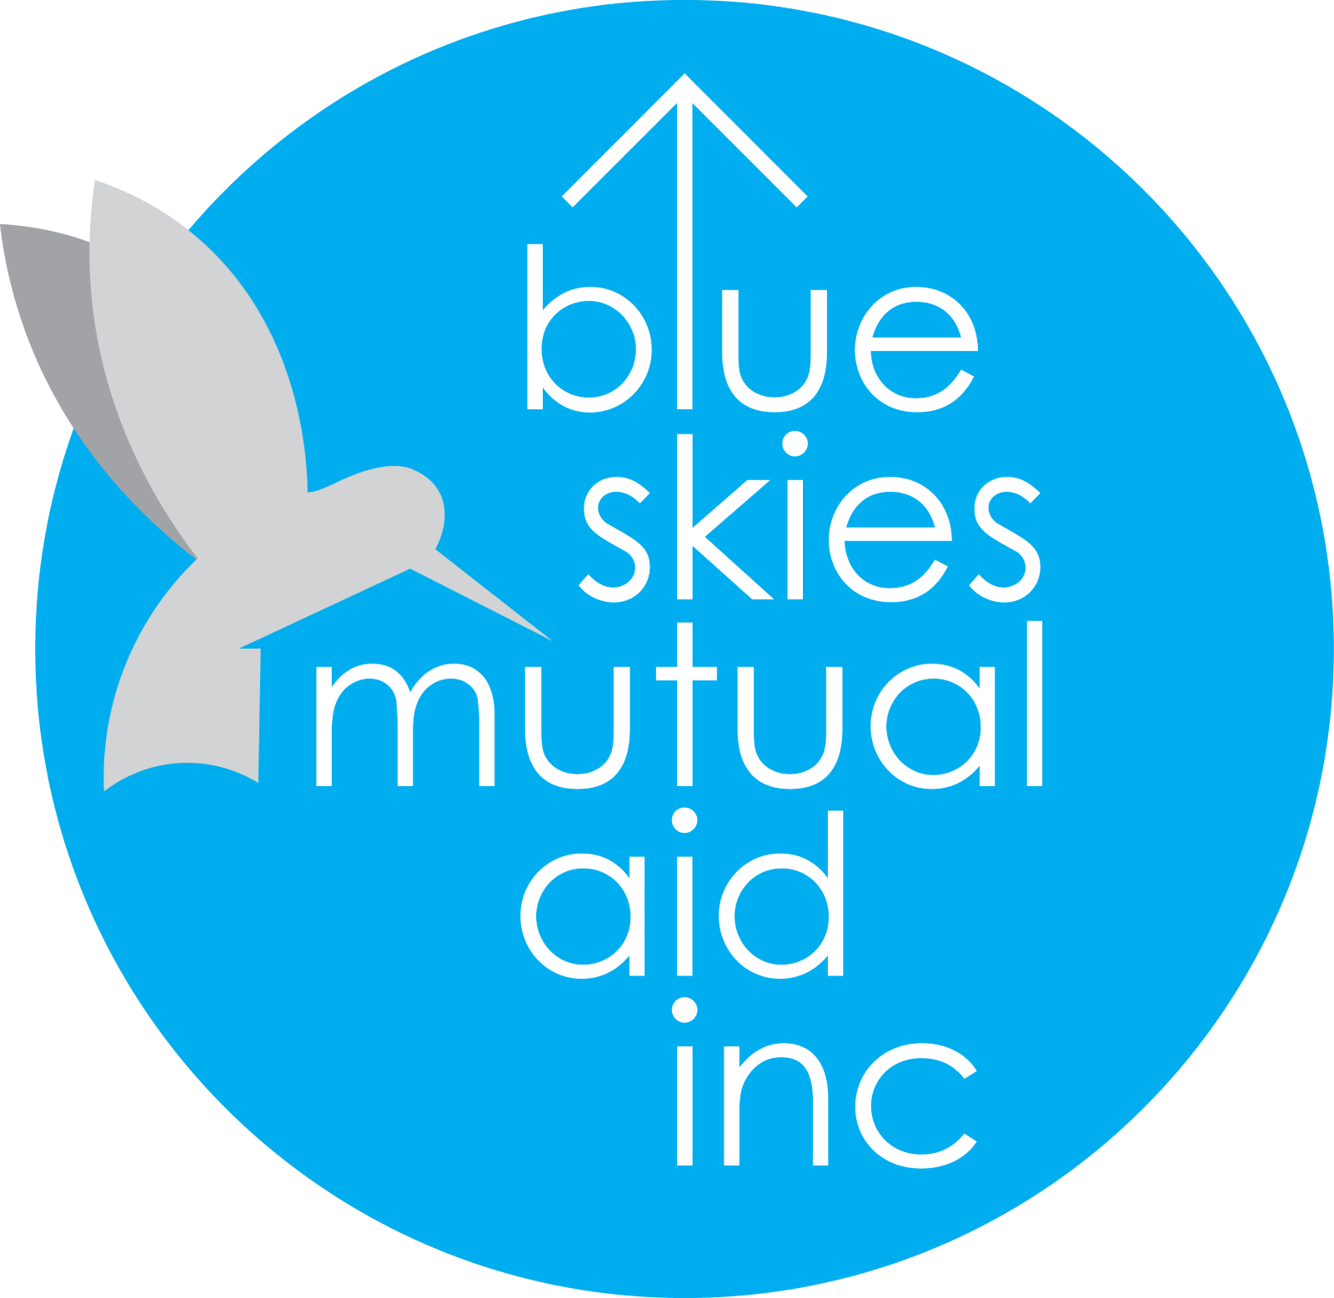

2022 State of the Skies Report

for

# Blue Skies Mutual Aid, Inc

## *Neighbors Helping Neighbors*

It is the mission of Blue Skies to promote harm reduction and alleviate poverty, suffering, and inequity in all forms through local mutual aid efforts. In the long term, the goals of Blue Skies are to make poverty as short-lived as possible for everyone that finds themselves in a harmful situation and to change the culture of Gaines County to one that encourages empathy, second chances, and equitable treatment and opportunities for all.

## Our Impact in 2022

## (April 19th to December 31st 2022)

For our direct impact with client services in 2022 we have:

* Assisted 2 people with finding both employment and housing
* Assisted 1 person with finding food assistance
* Gained a free 12’x12’ storage unit, built custom shelving inside, and used the unit to assist 4 people with donations such as clothing, baby supplies, kitchen appliances, and more
* Received 6 donations loads from the community and entered them into our donation inventory database
* Created online databases for housing and job options in Gaines County to use with clients as well as a sample lease form to give to prospective renters
* Gave away 4 containers of baby formula
* Raised over $4,000 for a widow and her son and helped make sure their medical debt was eliminated

For our organization as an entity in 2022 we have:

* Created a 501(c)3 nonprofit from nothing to fully operational with a full Board of Directors
* Created our Bylaws, Conflict of Interest Policy, Volunteer Handbook, and Volunteer Orientation Packet
* Connected all of our team with a communication app, organizational software, professional email, and accounting software
* Obtained a nonprofit PayPal account and a button on the website to collect donations
* Obtained a QuickBooks account and a corresponding debit card to go with it
* Began soliciting donations, raised over a $1,000, and created a budget board
* Created departments with specific goals and resources for each one
* Created a system to track and record automations with individual donor profiles
* Launched our online training system for volunteers, customized to each department
* Overall, in 2022 our records show volunteers spent $686.25 of their own funds
* Overall, in 2022 our records show volunteers spent 83 hours and 50 minutes of their time

For our branding and communications in 2022 we have:

* Created a logo, brand colors, consistent social media format, tagline, and mission statement
* Created and run a Facebook page, Instagram account, website, and email
* Partnered with Nicholson Insurance Agency and Cheryl’s Diner to implement all of the coffee mugs at the diner with our logo on the side of them
* Designed and handed out business cards within the community

For our community involvement in 2022:

* We helped out at the SISD Success Center's community garden, the first in Seminole
* We partnered with Seminole High School’s shop class led by Mr. Phillip to create multiple Little Libraries that will be placed in our community next year
* We successfully collected and donated locally-made crocheted animals for young patients at Seminole Memorial Hospital
* We volunteered with the Feed My Starving Children meal-packing event
* We volunteered as a team for the Seminole Strong backpack giveaway event

## Where We Can Improve in 2023

Overall, we have a few areas where we can seek improvement to better serve clients and refine our internal infrastructure behind the scenes.

* We had a small incident where our previous Communications Director forgot to respond to someone who was needing help with housing and by the time Jake saw the conversation and responded in his place it was a few days later. The client didn’t respond after that. It was just simple human error that could’ve happened to anyone so we just need to make sure our automated systems can catch things like that.
  + **How We Will Improve**: So long as Jake serves as the temporary Communications Director, he will make sure to have notifications enabled for Facebook and Instagram. When we install a new Communications Director, timely responses will be emphasized and notifications will be enabled on their devices. Jake will also supervise message communications more frequently as well.
* In 2022 we had high volunteer turnover throughout the year. Kasie, Rachel, and Evany contributed in the beginning but decided to leave later. Nathan had to leave due to moving across the country and Trevyn observed but didn’t participate so both of them were not counted as turnover. So that equals 3 out of 8 current volunteers, a rate of 38% turnover.
  + **How We Will Improve**: We will have a better volunteer orientation process, which we have already begun in December with a new Volunteer Orientation Packet, as well as more effective training which has also begun in December with our new online training courses for each department. In the future it will also help volunteers to be more invested if we are directly helping clients through a shelter facility where people can see the difference they make hands-on in a direct manner.
* Throughout the year, we had some trouble communicating what Blue Skies “is” and “does”. This is a common problem for organizations that are brand new and just getting off the ground.
  + **How We Will Improve**: The Blue Skies website is going to get a full redesign, making the home page clearer to newcomers about what exactly the organization “is” and “does”. It will also add more information in drop-down panels so as to not clutter up the main menu at the top. Photos and information about our actual impact in the community will also be posted along with information about other nonprofits in Gaines County. Also, once we bring in a new Communications Director, the task of coming up with a one or two sentence description of Blue Skies that volunteers can use will one of their highest priorities.
* Funding was a major obstacle to the smooth operation of Blue Skies, due to a brand-new Financial Department that didn’t have any experience with nonprofits. The department was also mostly focused on creating our 501(c)3 and getting all of our paperwork in order and focus on raising funds from within the community was put on the backburner because of that and it didn’t get the attention it needed.
  + **How We Will Improve**: We will onboard our new Financial Director, Cathy Hallum, in late January and have fundraising be her main concern. We have Nancy from 12th Street Bookkeeping to handle compliance paperwork and accounting so Cathy can focus on all the fundraising operations and work with Lonny, our major donor fundraiser, to make it happen.



My fellow volunteers,

I’m sure I’m not the only one who thinks it’s been a very interesting year for all of us. We were just coming out of all the Covid changes, many of us changed careers or hobbies, the weather wasn’t always the most favorable, and everyone generally just had a lot going on in their own lives. None of us are the same person we were one year ago.

But we all signed onto this little experiment to see if we could work together to create something that had never been done in our hometown before, a mutual-aid-based nonprofit focused on eliminating poverty and improving our community. I certainly didn’t know much about running a 501(c)3 when I was envisioning this organization but I realize now that if I had waited until the perfect conditions to begin I would still be alone, dreaming of change that would never come.

It is with a most sincere heart that I would like to say “Thank You” to each and every person who has brought us to where we are today, even those that aren’t with us anymore and are missed. Through it all we accomplished so much and it is my pleasure to announce at the end of 2022 that the state of the sky is blue. Thank you and have a wonderful night everyone.

Sincerely,

Jake Froese

Founder

2022 State of the Skies Verdict:

BLUE