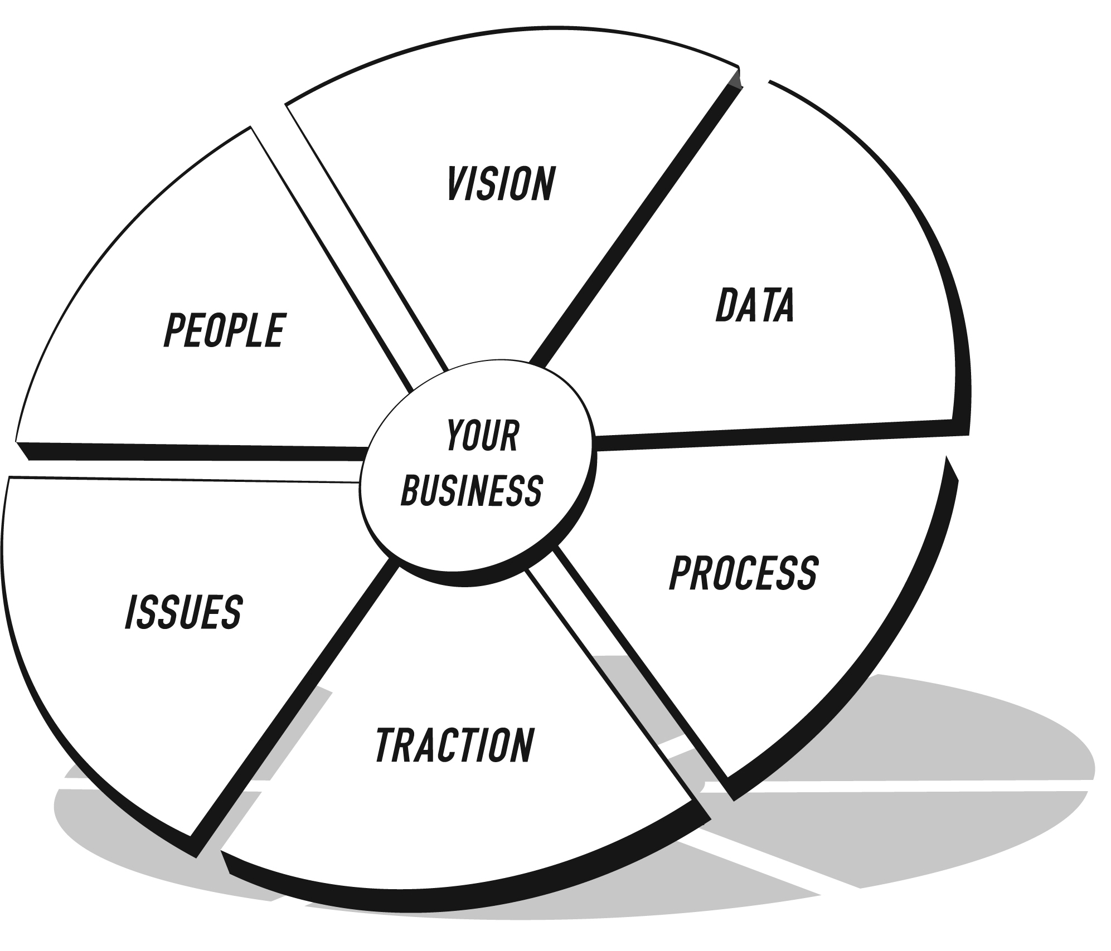

**THE EOS MODEL™**

THE VISION/TRACTION ORGANIZER™

**The Hope Line / Dawson McAllister Association – Q1 2021**

**VISION**

|  |  |  |
| --- | --- | --- |
| **CORE VALUES** | 1. Keep **GOD** first through obedience and sharing the Good News 2. **PRAYER** is the foundation of every relationship, opportunity and decision 3. Build **UNITY** by the unselfish pursuit of our core purpose 4. Be **RELEVANT** by understanding the culture and how to communicate with them 5. Invest in **PEOPLE**, treating everyone as we wish to be treated 6. Pursue **EXCELLENCE** by doing our best work everyday regardless of circumstances | **3-YEAR PICTURE™** |
| **Future Date:** December 31, 2023  **Revenue:** $2.50 million  **Reserve:** $750K (Cash on Hand EOY)  **Surplus:** $450K  **Measurables:**   * 60% spiritual intros/conversations chat > 10 min. * 15% Gospel Presentations from Chats with Spiritual Conversation   **What does it look like?**   * Maturing our technology tools, including Virtual Coach, CRM & SOR * Live Chat: Right-sized and effectively utilized * Digital marketing bringing in donations from >2K donors * Staff growth (3+ FTE), including marketing, development, content creation, and partner relations * Marketing funnels well-defined & tracked * 5M cumulative unique visits to all platforms in 2023 * Well established planned giving / estate planning program * Continue to develop relevant content, including video * Joining with other influencers to broaden our reach * 100+ major donors (>$10K/yr.) * “Seed Planters” at scale * Broad & strong partnership program |
| **CORE FOCUS™** | **Purpose**: We Nurture Young People Through Crisis to Christ  **Our Niche:** We Run a Rescue Shop a Yard from Hell |
| **10-YEAR TARGET™** | **10 & 1**  10 million unique visitors to all our platforms, and 1 million Gospel seeds planted  **(in process – Jen “To Do”)** |
| **MARKETING**  **STRATEGY** | **TheHopeLine USER Demographic:** Teenagers and Young Adults, Especially Those in Crisis  **Five Uniques:**   1. Meet people where they are, whatever their struggle 2. Provide quality intelligent content 3. Present God’s grace, forgiveness, and healing 4. Maintain a rich network of referral partnerships 5. One on one coaching and prayer   **Proven Process:** **REACH** (disseminate clear thinking and right values), **RESCUE** (provide emotional and spiritual triage), **RESTORE** (connect those who hurt with those who can help)  **Guarantee:** Maintain an unbroken bridge of help, hope and trust  **DONOR Demographic:** Student conference and radio listener & guest alumni; People who have themselves suffered crisis, or their kids/grandkids.  **Proven Process: REACH** (identify and connect with likely promoters and supporters), **INFORM** (Cultivate their connections to our core purpose and work), **STRENGTHEN** (Develop tools and resources they can use), **INVOLVE** (Offer opportunities to make a difference)   * Establish a regular pipeline of new prospects * Promote the work to likely target audience as widely as possible * Share new updates on their preferred platforms * Make personal calls and visits * Addendums to original resources with a caregiver focus * Free webinars and teleconferences * Capture and share user success stories and donor support stories * As Donors, Prayer Champions, Email Mentors * In their own families, youth groups, churches   To serve other like-minded orgs |



**THE EOS MODEL™**

THE VISION/TRACTION ORGANIZER™

**The Hope Line / Dawson McAllister Association – Q1 2021**

**TRACTION**

|  |  |  |
| --- | --- | --- |
| **1-YEAR PLAN** | **ROCKS** | **ISSUES LIST** |
| **Future Date:** December 31, 2021  **Revenue:** $1.9 million  **Reserve:** $550K **(**Cash on Hand EOY)  **Surplus:** $100K  **Measurables:**   * 60% spiritual intros/conversations chat > 10 min. * 15% Gospel Presentations from Chats with Spiritual Conversation   **Goals for the Year:**   |  |  | | --- | --- | | 1. | 50+ major donor proposals | | 2. | Build digital donation system & acquire 600+ new donors | | 3. | Track & test monetizing “frequent chatters” | | 4. | Virtual Coach built to MAPP | | 5. | Web visits 3.0M+ and (TBD outcome goal – Jen) | | 6. | Produce & market “Pack Your Bags, Jesus Is Coming” podcast series | | 7. | Establish & automate a scorecard & dashboard | | 8. | Craft a brand migration strategy |   With your cursor in the last row, press Tab to add another row. | **Future Date:** March 31, 2021  **YTD Revenue:** $293.2K  **YTD Reserve:** $325K  **Surplus:** $15K  **Measurables:**   * 60% spiritual intros/conversations chat > 10 min. * 15% Gospel Presentations from Chats with Spiritual Conversation   **Rocks for the Quarter: Who**   |  |  |  | | --- | --- | --- | | 1. | Create & send major donor report and proposals. # is TBD | Tim | | 2. | Monitor, manage & report on the BBS rollout of Digital Donor Acquisition System (DDA). Recommend changes | Tim | | 3. | Recommend to L.T. (Leadership Team) a way to track repeat chatters in SOR | Micky | | 4. | Continue development, implementation and testing of gospel presentation through Virtual Coach | Jen | | 5. | Develop & implement a plan for more decision links | Jen | | 6. | Create , produce & release first two episodes of “Pack Your Bags…” | Rachel | | 7. | Develop & present 1st version of dashboard to L.T. | Micky | | 8. | Propose & present revised scorecard to L.T. by 1/7/21 | Stewart | | 9. | Complete brand migration study and report to L.T. | Tim |   With your cursor in the last row, press Tab to add another row. | |  |  | | --- | --- | | 1. | How do we maintain and develop valuable partnerships? | | 2. | Succession planning at all levels | | 3. | Need for core process documentation | | 4. | Develop / engagement with individual accountability charts | | 5. | Increase Spiritual conversations | | 6. | Increase chats | | 7. | Future plan for digital audio production (part of Rachel rock) | | 8. | Subscription services (9 topics) | | 9. | 2021 Donor Thankathon | | 10. |  |   With your cursor in the last row, press Tab to add another row. |