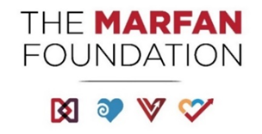

**Vision**

Cures for genetic aortic and vascular conditions.  

**Mission** 

 Save and improve lives, while creating communities, for all individuals with genetic aortic and vascular conditions including Marfan, Loeys-Dietz, and Vascular Ehlers-Danlos syndromes. 

**Critical Success Factors**   

* Be the preeminent provider of information and programs for affected individuals, families, and medical professionals.
* Propel critical scientific discovery resulting in the best possible outcomes for affected individuals.
* Operate as a highly inclusive, effective, and efficient organization.
* Ensure significant financial resources to advance the mission.

**Strategic Opportunities for FY24-FY26**

* Widespread adoption of a mobile-centric solution that allows for simple, frequent and personalized engagement between those who have or suspect they have connective tissue conditions, their support network, expert physicians and the resources of The Marfan Foundation.
* Create a Corporate Alliance to achieve deep partnerships with a minimum of 5 to 7 healthcare and consumer brand companies to support the Foundation’s mission.
* Secure $5 million above and beyond the current level of research funding.
* To establish an expanded international presence including an international federation of stakeholders that would dynamically collaborate, share valuable knowledge, and drive research innovation.