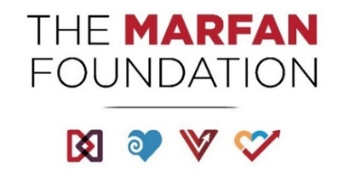

**2022-2023 Strategic Plan Summary**

**Vision**

Cures for genetic aortic and vascular conditions.

Mission

Save and improve lives, while creating communities, for all individuals with genetic aortic and vascular conditions including Marfan, Loeys-Dietz, and Vascular Ehlers-Danlos syndromes.

Critical Success Factors

1. Be the preeminent provider of information and programs for affected individuals, families, and medical professionals.
2. Propel critical scientific discovery resulting in the best possible outcomes for affected individuals.
3. Operate as a highly inclusive, effective, and efficient organization.
4. Ensure significant financial resources to advance the mission.