Galapagos, September 07, 2024

**REPORT OF THE IMAHELPS ECUADOR MEDICAL & DENTAL MISSION PROGRAM TO BELLAVISTA PARISH, SANTA CRUZ ISLAND, GALAPAGOS, ECUADOR - SEPTEMBER 2024**

Our nonprofit, IMAHELPS ECUADOR (Sioux Falls, South Dakota) provided free medical & dental care from 09-02-2024 to 09-05-2024 in the Sports Center building in the town of Bellavista, on Santa Cruz Island, Galapagos. Our team was composed of Dr. Nina Khin Maw Maw, Dr. Carmen Prieto, Dr. María José Schurjin, Dr. Lucy Baldeón, Dr. Luis Diniz, Dr. Antonio R González, Ms. Estefany Chuquitarco, Ms. Inés Allen, Mr. Tracey D. Allen, Eng. Jorge Criollo, Ms. Andrea Cueva and Mr. Kevin Lara; doctors specializing in Internal Medicine, Gynecology, Pain Therapy, Pediatrics, Dentistry and logistics personnel.

In the four days of the medical mission program, we provided 776 clinical services to 467 people, who were distributed in 126 services in General Medicine and Internal Medicine, 78 in Pediatrics, 34 in Gynecology, 92 in Dentistry and 446 in pain treatment.

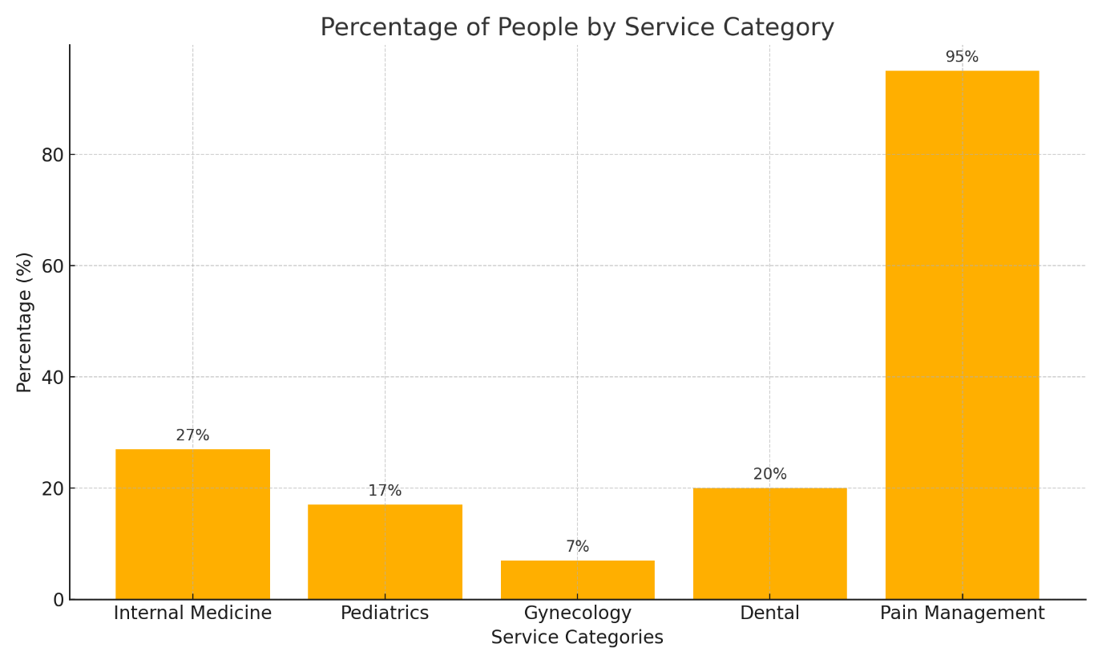

64.8% of the total number of people attended were women and 35.2% were men. The age group between 31 and 54 years old was the most prevalent.

In the field of General Medicine, Internal Medicine and Gynecology, we have been able to observe in the population served, a significant prevalence of diseases such as type 2 diabetes, hypertension, overweight, obesity, varicose veins, common cold, gastritis, reflux, dermatological infections, vaginal and external genital infections.

In Pain Therapy we treat pathologies related to posture and arthralgias caused by joint wear such as: cervical, dorsal and lumbar spine pain, spurs, heel and knee pain, carpal tunnel, migraines, dizziness, facial paralysis, ulcers, shoulder and ankle pain.

In Pediatrics, we treated upper respiratory, dermatological and behavioral conditions. In addition, we could notice that most children came for a well-child check-up.

In Dentistry, we observe a high prevalence of occlusal caries, bottle caries, dental calculus and fistulas in gums. In addition, we perform simple and complex restorative procedures, teeth cleaning, and prophylaxis.

IMAHELPS ECUADOR was able to deliver 605 prescriptions from our set up pharmacy. All remaining medicines, prenatal vitamins and children’s vitamins were left with “Fundación Paraiso Solidario” to be given freely to the community we for their future needs.

In this mission pragram we have confirmed that access to specialized health services, as well as medicines is restricted due to the distance of the islands from the mainland, for this reason it is important to support the effort made by the Parish GAD of Bellavista to improve the health of the inhabitants.

We believe that it is important to conduct information campaigns on issues related to healthy habits in terms of balanced eating and physical activity, both preventive and specific for each pathology, oral hygiene habits, postural and ergonomic education, preventive and corrective.

We are grateful for the opportunity to have been able to learn about the problems of the population of Bellavista and we hope to have contributed favorably to the health of its inhabitants.

Ms. Inés Allen President

**IMAHELPS ECUADOR**

**IMAHELPS ECUADOR, Inc.**

**C/O Ines Allen, President**

**9432 W. Liam St. Sioux Falls, SD 57106-7339**

**(760) 485-8964**

**www.imahelpsecuador.org**