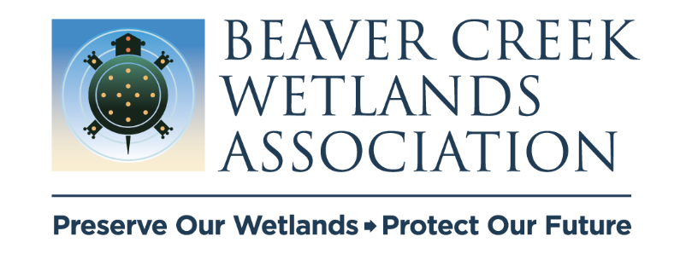
July 2024
BCWA 3-year Strategic Plan
Objectives & Goals

Strategic Priority 1: Maintenance of Land
Owner: Jim S., Skip & Dave Nolin
Objective: Develop and implement a comprehensive plan for maintaining trails and infrastructure on all properties
Goals:
- Develop a map of each property that defines habitat types, trails, and boardwalks.
- Develop an annual calendar of maintenance activities.
- Assign a leader/champion for each property who will manage the schedule of activities
- Hire a Land Manager in 3-5 years.

Strategic Priority 2: Habitat Management
Owner: Dave Nolin? And Austin
Objective: Manage the ecological health of selected properties within the wetland corridor
Goals:
- Complete cover mapping
- Develop and implement an ecological management plan for 5 properties, in addition to those already under active ecological management.
- Decide what can be completed by volunteers & what needs to be contracted.

Strategic Priority 3: Spotted Turtle Trail
Owner: Ken
Objective: Complete additional phases of the Spotted Turtle Trail
- Complete Phases 3 & 4, which are in process and fully funded.
- Complete Phase 5, Beavercreek Wildlife Area & connections to JABR & Koogler, contingent on funding (75%) from ODNR.
- Develop an executable plan and funding strategy for Phase 6

Strategic Priority 4: Funding
Owner: Jacki
Objective: Increase fundraising to sustain and grow the organization, including addition of a Land Manager
Goals:
1. Expand the fundraising including marketing, events, fundraising campaigns, stewarding current & potential donors, and business/
corporate sponsorships.
2. Implement a planned giving program and a recurring donor program.
3. The Board of Trustees will be responsible for growing the endowment with $10,000 of new money over 3 years
4. Grow fundraising capacity on the Board: Bring in new board members to assist with fundraising including opportunities to make new
connections.

Strategic Priority 5: Volunteers
Owner: Beth
Objective: Recruit, Engage, & Retain Volunteers
Goals:

1. Fully implement the Adopt A Trail program. Create groups of approximately 4 volunteers to collaborate and take "ownership" in maintaining
a park/reserve in the Beaver Creek Wetland corridor.
2. Increase Volunteer Retention Rate to 40%
3. Increase the average logged hours per volunteer to 33

Strategic Priority 6: Education

Owner: Shandah
Objective: Provide education programming
Goals:
1. Continue and refine 13 existing educational programs.
2. Maintain or increase attendance from 2023 levels
3. Develop a group of 10 volunteers to run educational events.
4. Create an internship program that meets the needs of BCWA and provides insights into the fundamentals of BCWA
for at least one intern per year.

