Oxford Area Historical Association
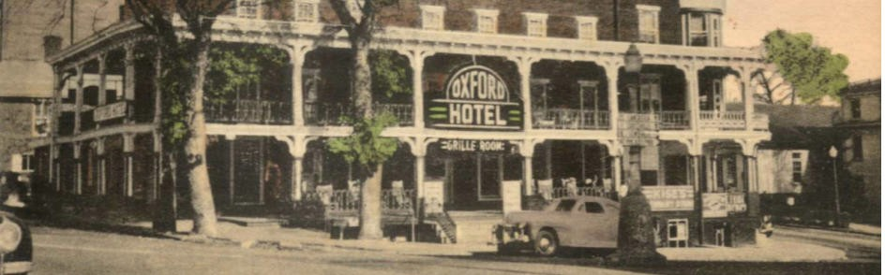

Strategic Plan
2021-2024

Approved by the OAHA Board of Directors
June 2021

Organizational Overview
The Oxford Area Historical Association (OAHA), which was founded in 2000 by Dr. Faye Doyle, is a local group of volunteers and members whose mission is to preserve and promote the historical significance of the Oxford Area. We present monthly programs on a variety of historical topics, record oral histories of long-time Oxford residents, and have organized walking tours, co-sponsored reenactor programs in the school district, and arranged trips to historical sites. In 2014, an Archives Committee was created to acquire and process documents and objects related to the history of the Oxford Area. Our Archives Collection is now housed at 140-142 Locust Street in downtown Oxford.

The mission of the Oxford Area Historical Association is to preserve and promote the historical significance of the Oxford area, educate the community on historical interests, and to encourage the economic vitality of the Oxford area through historic preservation.
Mission Statement
Vision Statement
The vision of the Oxford Area Historical Association is to build a shared community legacy for the future by preserving our past.

Education Preservation Community
Responsibility
Core Values

Summary
In the spring of 2021 OAHA’s board of directors developed this strategic plan for 2021-2024 in order to align their vision and actions, improve performance, and enhance organizational growth. OAHA board members and external stakeholders assisted with plan development. The board held a strategic planning retreat and confidential interviews were conducted with both board and community members. A total of 26 interviews were conducted.
The board identified five strategic priorities based on the feedback received: Facility and Space Needs; Educational Access; Preservation and Stewardship; Increased Community Engagement; and Building Organizational Capacity.
OAHA will continue to pursue facility and space needs, engage the community in meaningful, educational and memorable experiences, strengthen and steward the Association’s collections, and enhance organizational outreach.
Page 1 of 7

Strategic Objectives

- Continue to pursue facility and space needs.
- To ensure access to quality educational programming focusing on the history of Oxford and the surrounding area.
- To preserve the history of Oxford and to steward our historical archives and collections.
- To increase community engagement.
- To build organizational capacity.
Strategic Objectives

Financial Plan

*As needed, these are things to be taken into consideration if it is determined that any of the four strategic priorities will need a financial investment, such as staffing, building and facility needs, etc. Items could be listed here underneath each strategic priority (or under action step in the operational plan) with a potential cost attached. This is a working document to refer to yearly when creating the next year's budget.

Page 2 of 7

Strategic Objective 1: Continue to pursue facility and space needs.
Strategic Objectives

Major Initiatives & Goals
  - Create an exploratory committee dedicated to looking at options for expansion.
    - Contact list of individuals who expressed an interest in participating.
    - Create a work plan for this committee.
    - Determine space needs.

  - Explore facility options for expansion based on space needs.
    - Look into local rentals.
    - Look into collaborations with other nonprofit organizations.
    - Look into facilities for purchase.
  - Explore financial needs based on determination of expansion options.
  - Morph Exploratory Committee into Capital Campaign Committee as needed.

Strategic Objective 2: To ensure access to quality educational programming focusing on the history of Oxford and the surrounding area.
Strategic Objectives
Major Initiatives & Goals
  - Increase attendance at programs and events.
    - Refine existing and create new programs and events.
    - Continue to offer programs virtually in addition to in-person.
    - Focus on making connections between Oxford's past, present and future.
    - Seek community input on topics of interest.
    - Define potential topics that highlight our collection.
    - Seek out relevant presenters.
    - Present programs on the diverse history of the area.

  - Collaborate with local schools and youth organizations.
    - Determine schools for outreach - Lincoln University, WCU, Oxford High School,
Penn's Grove School, others.
    - Do outreach to volunteer organizations such as Scouts.
    - Do outreach to local churches
    - Meet with local educators and volunteer leaders to determine interest and focus areas.
    - Present programs of interest to local students.
    - Offer opportunities for students seeking involvement (creation of OAHA video, creation of QR code history tour, etc.)

Strategic Objective 3: To preserve the history of Oxford and to steward our historical archives and collections.
Strategic Objectives

Major Initiatives & Goals
  - Seek interim solutions to improve usage of existing work and storage spaces.
  - Increase accessibility for research of collections.
    - Continue to digitize oral histories and programs.
    - Increase hours we are open.
    - Ensure COVID-compliant environment.
    - Continue to catalog items as received.
    - Start a collections wish list.

Strategic Objective 4: To increase community engagement.
Strategic Objectives
Major Initiatives & Goals
  - Increase community awareness of OAHA.
    - Review logo and marketing materials.
    - Identify core audiences.
    - Identify ways to do outreach to school families.
    - Market to new residents through participating in Chamber welcome baskets.
    - Coordinate with Chamber and OMI to do displays in empty storefronts.
    - Continue to write articles for the Oxfordian.
    - Continue to participate in community events and professional networking groups.
    - Maintain Internet presence - website, Facebook, etc.
    - Publish written materials on local history (books, calendars, etc.)

  - Increase volunteer opportunities.
    - Create volunteer job descriptions.
    - Target recruitment of volunteers.
    - Establish volunteer training sessions.
    - Implement annual volunteer recognition event.
  - Foster community involvement.
    - Present a united, professional and positive image.
    - Organize trips to locations of historical importance.
    - Present OAHA Historic Preservation Achievement Awards.

Strategic Objective 5: To build organizational capacity.
Strategic Objectives
Major Initiatives & Goals
  - Strengthen the OAHA board
    - Formalize board processes and develop board job description.
    - Develop a board skills matrix.
    - Seek out board development training opportunities.
    - Seek out new board members.
  - Continue fundraising for sustainability and expansion.
    - Create a one-page annual fund development plan.
    - Create a capital and an in-kind wish list.
    - Identify, solicit and cultivate individuals, organizations and foundations for annual, major and planned gifts.
    - Morph the expansion exploratory committee into a capital campaign committee if needed.
    - Continue to fund an organizational consultant to assist with implementation of 2021-2024 long-range plan.
  - Investigate funding for a part-time staff position.

