2017 Annual Report
Dear Friends of Orphans Africa,
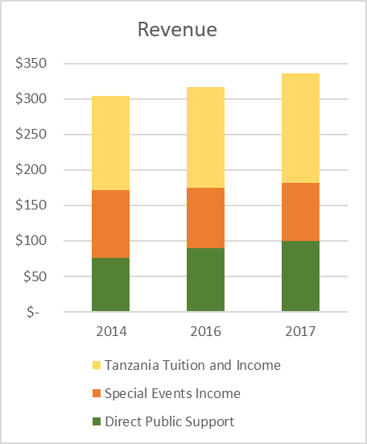
Orphans Africa continues to operate a tight ship in the US, and our funding going to Tanzania is again on the upswing. Our ability to leverage your contribution with those of our supporters in Tanzania creates a dynamic and effective platform to better the lives of children. We provide education, food, clean water, medical insurance, housing, and love!
($ in 000s)
In 2017, total income increased 6% to $186,400 compared to $175,100 in 2016. The funding we sent to Tanzania increased 20% to $103,000 in 2017 from $86,000 a year ago. In addition, our in-country revenues from tuition in 2017 grew 9% to $154,600 in 2017 from $141,700 in 2016. With these funds, we have educated, on average, 242 students per year for the last3 years.
OA’s self-sustaining model for the schools is designed to provide education to some of the poorest children on earth, while generating sufficient revenues from tuition from families that can afford it. In addition to tuition fees, several of our schools have agricultural production that supplements nutrition for the children and generates revenue for the school. Because of the high quality of education we deliver, kids with working parents pay to come to your schools and orphans come for free. Over the past 3 years, Tanzanian parents paid $429,730 to support your schools.
The in-country revenues are possible because of the infrastructure, we have built that provides the comprehensive and successful educational system we have operated for more than a decade. In 2017, we accomplished a great deal including the following projects:
- Completed the Mwaji Boys’ Dormitory, some furnishings and a new restroom facility;
- Completed the kitchens and dining hall furnishings and equipment at 2 schools;
- Started the Isandula Vocational College driving program;
- Provided medical insurance for 181 orphans;
- Built barns and hives for goats, chickens, cows, pigs and bees for self-sustaining income and nutrition;
- Installed solar power improvements;
- Rebuilt Mwaji School toilet;
- Significantly reduced diarrhea illness with clean water from the deep drilled well last year;
- Resupplied laboratory chemicals;
- Built replacement roof for the lab due after a storm tore the existing roof completely off the building;
- Provided food support for children ages 2 to 16.
We really do run a lean organization. Our core operating expenses, excluding special event program costs, run about $4,400 a month. The major expenses are payroll costs for our part-time administrative manager, Stephanie Miller, printing, postage, software, contract services and rent. Our bookkeepers have provided exceptional help in our accounting work, which keeps us up-to-date and in compliances with state and federal agencies.
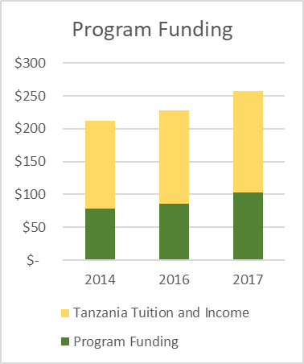
We have great partners in Tanzania working together with you to educate the orphans. Not only do they provide financial support from tuition to our schools, they also help maintain the facilities and work with us to build new infrastructure. To save money, they even learned how to make bricks to build the dining hall. These folks make a huge difference in our schools and are great supporters of our students.
($ in 000s)
Thank you so much for supporting our schools and our students. We look forward to seeing you at our auction each March and at our Zog’s events in August. To our financial contributors, our volunteers and our board members, we thank you for all you do.
Sincerely,

Carl Gann
President

