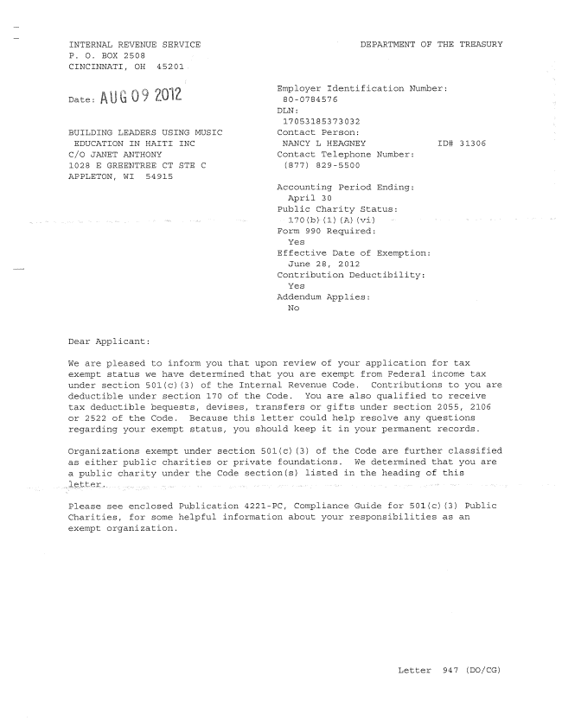
:
-2-

BUILDING LEADERS USING MUSIC EDUCATION
Sincerely,

Holly O. Paz
Director, Exempt Organizations
Rulings and Agreements
Enclosure: Publication 4221-PC
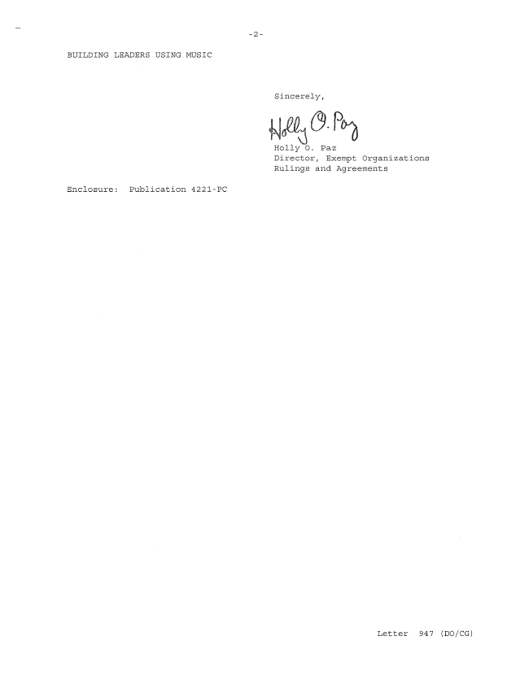
BUILDING LEADERS USING MUSIC
Sincerely,
W Holly O. Paz Director, Exempt Organizations Rulings and Agreements
Enclosure: Publication 422l—PC
Letter 947 (DO/CG)

