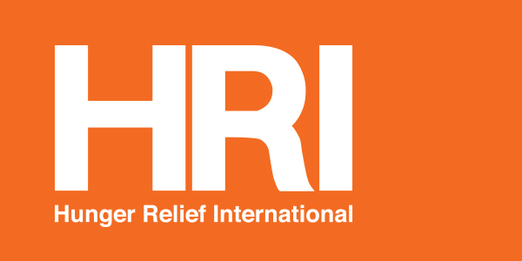

Proposed Strategic Goals

Mission
Hunger Relief International (HRI) is a Judeo-Christian organization that works to improve and protect the lives of children and families living in extreme poverty by building resiliency, fighting hunger, promoting family unity, and increasing self-sufficiency. HRI does this through direct programming and by raising public awareness.

Vision
HRI aspires to ensure that children and families living in extreme poverty have their basic needs met including equitable access to nutritious food, education, clean water, healthcare, sanitation and safe living environments. We envision a world in which the girl child and women especially understand their rights and that these rights are respected by society, giving them a voice and decision making power in their lives, homes and nations.

Strategic Goals:
- To continually strengthen our commitment and efforts to end extreme poverty, a major contributor to so much suffering in the world today, particularly the pain of hunger and malnutrition
- To raise up generations of girls and women who understand their basic human rights including equity in all forms, their importance in civil society, and the economic power that lies within their reach
- To deepen our commitment to the highest standards of professional competency and service as well as strong, equitable organizational leadership and governance

