Southern California Golden Retriever Rescue
2014 Annual Report

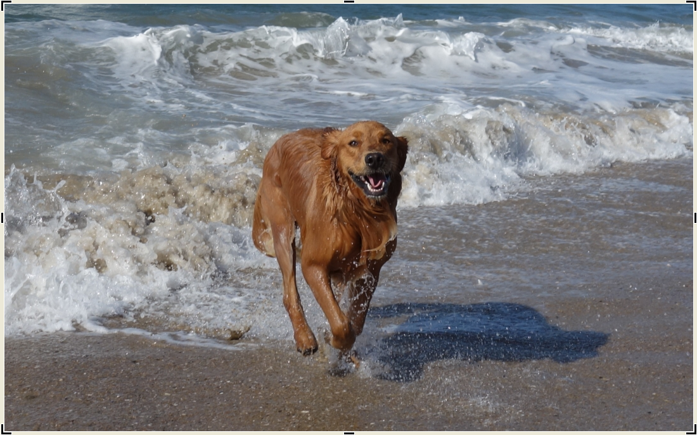


Letters from the Presidents

It has been a great journey and experience for me these past two years as President of this wonderful rescue. I want to thank every volunteer who spends countless hours helping save these beautiful second- chance Golden’s.

I’m handing the reigns over to Karyn King who I know will bring great ideas and move this rescue forward in the years to come.

This past year has been both challenging and rewarding. We have experienced very expensive medical bills but thankfully had some very generous donors helping us financially. We have adopted out countless Goldens to wonderful families. And sadly we have had to say good-bye to a few of our permanent foster dogs as well as some of our adopted dogs who have crossed the Rainbow Bridge.
We have signed up many new and very enthusiastic volunteers, our foster families are getting more involved and our fundraisers have been very successful.

We all should be very proud of what we have accomplished this past year and since we opened our doors in 2008.

I am confident that Southern California Golden Retriever Rescue will continue to strive to be the best rescue in California and the country.

Golden Paws,
Jenni Morita
2013/2014 President

I began volunteering for SCGRR in September of 2010. Since that time I have watched our rescue grow and save over 2,000 Golden Retrievers, Golden Mixes and a few Old English Sheepdogs! I have always been so impressed with the level of dedication our volunteers and donors have shown. I am so very proud to serve SCGRR as the incoming President and I hope to serve with the same dedication as those that I volunteer with. Everyone’s time and effort is invaluable and every dollar raised is a blessing to the sick, abandoned and neglected Goldens in need that we all love so much.

With deep sincerity – thank you all for your Rescue Hearts,
Karyn King
2015 President

SCGRR 2014 Rescue Statistics

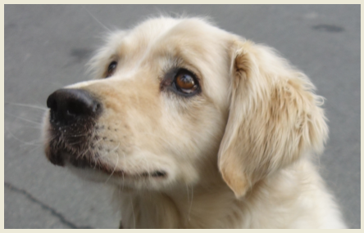

- Rescued 342 Dogs in 2014
- Adopted out in 299 in 2014*
- 2014 National Ranking?

*some dogs became permanent fosters, crossed the rainbow bridge or were transferred to Homeward Bound

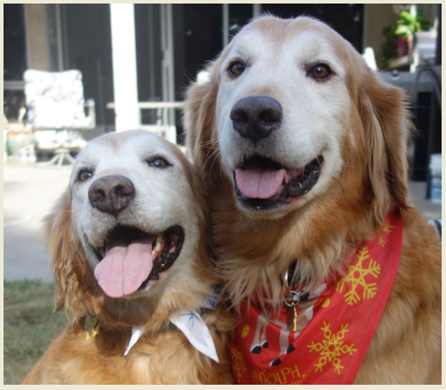
2014 Rescue Income and Expenses

Income Source | Income Amount
Grants | $12,327
Bequeaths | 68,670
End of Year Gifts | 17,828
Home Interviews | 21,731
Monthly Donors | 34,256
Adoption Fees | 97,688
eBay Auction | 13,580
Events | 20,549
Donations  Annual Calendar | 97,300 includes sponsorships  11,025

Expense Item | Expense Amount
Animal Welfare (including vet costs) | $294,297
Operating Expenses | 24,769
Fundraising Expenses | 24,934

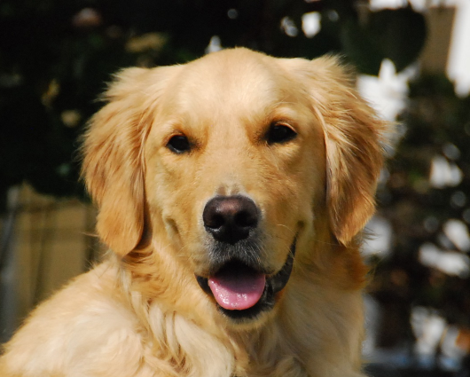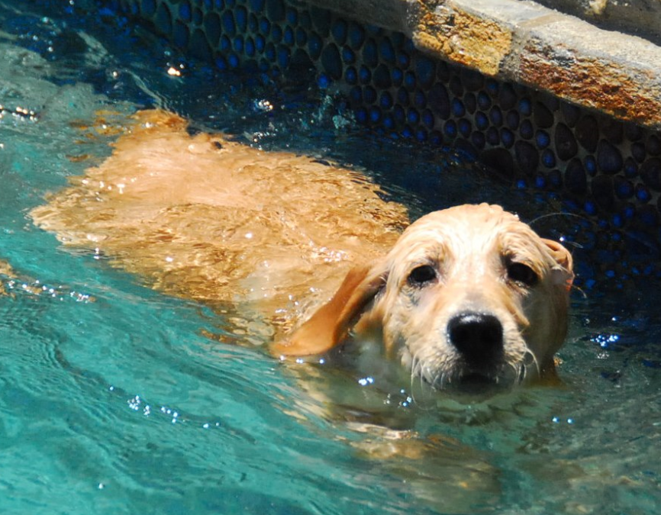
Permanent Fosters – Ongoing Love and Care

Not all of the Goldens we rescue leave us for permanent homes. Some are not adoptable for health reasons so they remain with the rescue in committed foster homes who love and care for them without the worry of financial burden. Your very generous donations and our successful EBay auction in November of each year help us to continue this valuable part of rescue. Some of our permanent fosters have forms of cancer, heartworm, hip dysplasia and arthritis; all issues that need continued financial support. Here are 4 of the 22 we currently have in the program.
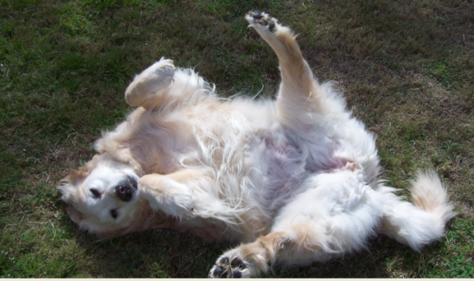
Alaina
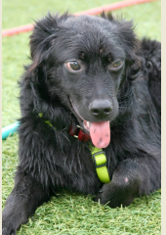
Bugsy
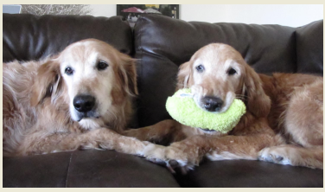
Fetch and Carry
Sugar Face

Sagen was taken to a shelter at 12 years old. Lois, an original SCGRR volunteer, rescued him from the shelter and learned while there that the reason he was given up after 12 years was that he struggled to get up in the mornings. He was terribly overweight at 118lb, his teeth were rotten and bleeding and he had 7 very large cysts that needed removing.
Sagen went in for surgery; he had the 7 teeth and 7 fatty tissue cysts removed, one of which had ruptured but with all of his fur it wasn't first noticed. For the next while Sagen recuperated in one of our loving foster homes. His first few days were not just spent recovering from the stress of surgery but also the stress of not being with the only family he knew all his life.
Soon Sagen began doing some light walking that then progressed to socializing at the local dog park and then even some fast waddling when he got a new foster brother! Sagen was in foster care for 2 months and lost 12lb in weight and after the first week being showered with love, hugs and kisses his tail never stopped wagging. He has now been adopted by his foster family who realized they couldn't live without this happy old man in their lives.

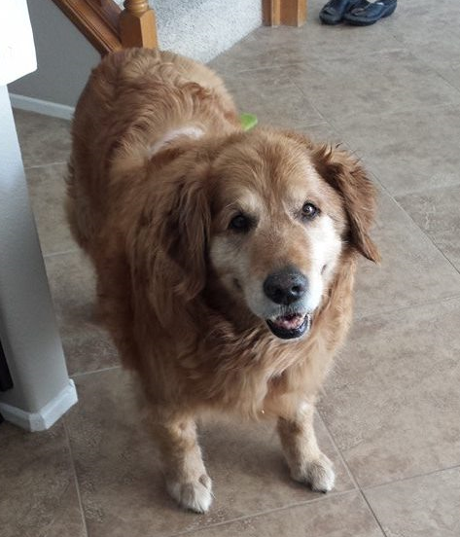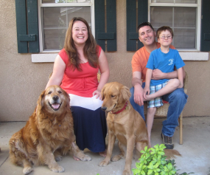

A New Leash on Life

Budster lost the only family he had ever known when they moved out of state without him. Based on his age alone he was a candidate for our permanent foster program. Little did we know that this 14 year old gent had discovered the fountain of youth and had the energy of a pup half his age. Declared a clean bill of health we were optimistic that he would find his forever family.

Buddy was on the website for three months, about half of the time he spent in foster care, waiting for his new family to find him. During that time he experienced a lifetime of adventures; Halloween costume parties, flirting with all the ladies at the local wine bar, camping and fishing in the mountains, sailing, beach adventures and a paddle boarding photo shoot for the family Christmas card. Ball obsessed he would play non-stop for hours.

We knew it would take a special family to look beyond the years and see his inner ‘pup’. His family reports that “He is just like Benjamin Button in dog form,” the longer he is with them, the younger he appears to get. They love him more and more each day.

Buddy now has a dad that works from home so some days Buddy sleeps-in and they hang out taking “ball breaks” whenever possible. Buddy’s back legs are getting stronger every day thanks to his daily workout shagging balls. Some days Buddy gets up early to accompany mom to work at the treatment center where he's been crowned the new therapy dog. He has his very own corner bed in the office and receives loads of attention from all of the girls…they absolutely adore him.

So who rescued who? Buddy touched the hearts of all of those he met on his journey through SCGRR and has made this new family complete.

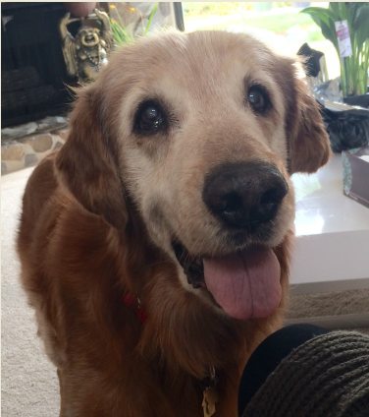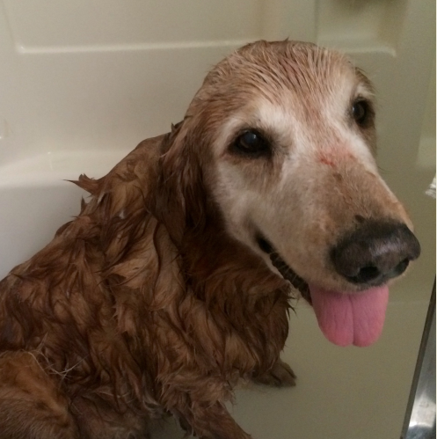

Caring for Those in Their Final Days

Sweet Charlie AKA Chuckie was turned in by his owner because they were moving and could not take 2 dogs. Charlie was limping and not putting any weight on his back right leg at all. We were told he was running and had sprained his knee. His medical records were spotty and his previous vet noted “possible ACL tear.” Unfortunately our rescue vet Dr. Rachel Tuz noticed something odd on his x-rays – something that looked like bone cancer. Poor Charlie, so sweet and beautiful, was dealt a bad hand as too many Goldens are.

It was decided that he would be made part of our Permanent Foster program and that the rescue would lovingly care for him for as long as he had left. We amputated his leg to control the pain knowing that the cancer had spread microscopically and that the best we could hope for was 6 months to a year.

He joined a foster family with 2 other Goldens – one young and one sugar-faced. He played with the young one and snuggled with the older one. Charlie was pure joy with the happiest Golden smile ever – he really looked like a Teddy Bear with the curly fur on his ears.

He was a bright spot in their lives for too short a time. He had 5 wonderful pain-free months chasing his tennis ball and swimming at the Doggy Water park. The rescue paid for his surgery, his medications and his physical therapy. A wonderful donor paid $500 to get him a wheelchair so he could get around.

Charlie passed away peacefully in his sleep with his foster brothers close by. He will be forever missed by everyone who ever met his happy smiling face.
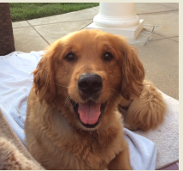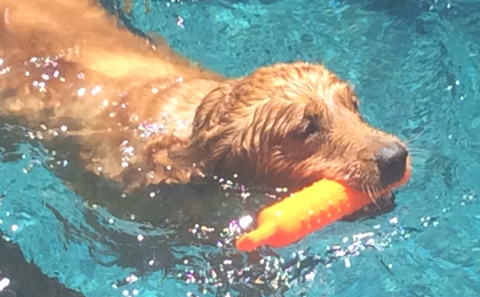

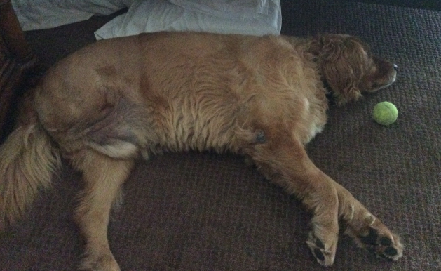
The Pup in the Bubble

Atticus was found on Craig's List....”9 week old Puppy, free to a good home, needs some medical.” We called and a volunteer rushed to pick him up. Apparently his owner had him in the backyard with her Husky's and one of them crushed Atticus' skull when he got to close (she stated she was in the middle of feeding the Husky.)
Our volunteer scooped the little guy up and took him straight to our fabulous Vet Partners CVS in Murrieta. He was rushed into having a CT Scan, tests and an exam by the eye dogter. Results were a crushed skull, crushed left nasal passage, a crushed right eye and completely blind in it, multiple puncture wounds and the bone plate protecting his brain from the nasal passage was bent a little. The only thing that wasn't damaged was his spirit; this pup had absolutely no idea that there was a thing wrong with him!
While we let him heal and grow (we needed his skull to finish developing) he pretty much stayed in a "bubble." He was not allowed to play with other dogs but his foster family compensated by playing with him and occasionally letting him quietly visit with his foster fur brother and sis. He also got to play in a small kiddy pool which he loved! At 8 months old he went in for another CT Scan and we found his upper permanent teeth where still not in but were imbedded in his gum so off to the dentist he went and had a couple of teeth pulled before they could abscess. He is such a little trooper and never complains.
Atticus has his own Facebook page with 1,655 fans and counting. https://www.facebook.com/pawsitivelyAtticus.
We have paid for all his medical bills through our wonderful supporters doing auctions and straight donations under his name whenever he needed something done. He is truly loved by a village and belongs to each and every one of us! He will be on the website in 2015 looking for that very special furever family.
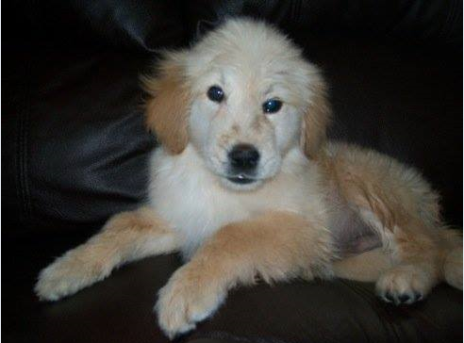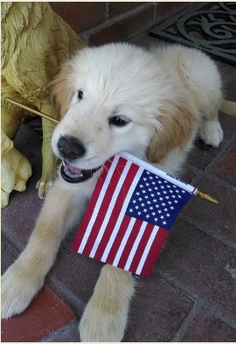

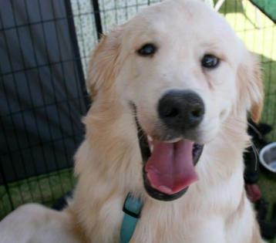
From Roaming Alone to Re-homed!

Bones was found roaming the hills in Riverside county. He was emaciated, had maggots in his ears and was in desperate need of help. A kind soul saw him, managed to coax him to her and she turned him into rescue to see if we could help him. Absolutely we would!
For the next few months Bones received love, attention and gentle pets and voices to help him recuperate. Under the watchful eye of one of our amazing vet partners he began to put on a small amount of weight and gain strength to stand and move around again. However, with that, came the realization that Bones was having trouble standing without occasionally wobbling or falling over. He had terrible ear infections which were possibly attributed to the balance issues. Samples from his ears had to be sent to the lab for them to grow the infection and then test to see what would clear it - this procedure is known as a culture. Results came back and had a staph infection and once we knew that we were able to begin to see improvements from the new medication. However, the balance problems persisted.
Then he had a seizure; it lasted 40 minutes. His foster family rushed him to the emergency vets where he remained for a night or two. The conclusion was it was likely epilepsy. Bones continued to have seizures every other day for the next week. Bones' home vet worked tirelessly with him and his caretakers to get the right balance of medication for him. Over the next 3-4 weeks, Bones gained 25lb to get him back to a healthy weight, and he went 4 weeks without a seizure, and when the next one did come it lasted only about 45 seconds. Bones was on the mend!
Bones remained in foster care long enough to enjoy the snow over the Christmas break with his foster siblings and then with clearance from his dogtor, he headed off to his furever home whose family was looking to love him like never before.
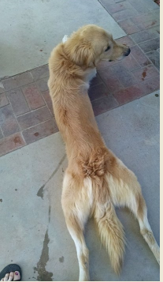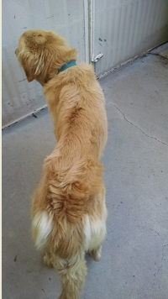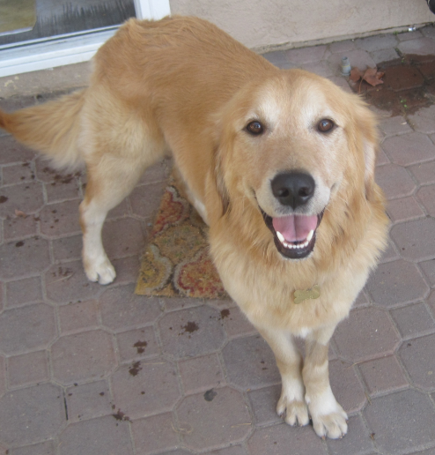

Rags to Riches

Poor sad Autry was kept chained up in a dirt backyard his whole life (6 years.) No one to play with, no one to give him love and affection, all alone with nothing to do and no one to love. A rescue friend had noticed the poor dog’s situation and got up the courage to knock on the owner’s door and begged him to give up the dog. The owner finally gave him to her and she turned him over to SCGRR.
Autry had to learn a lot of new things like not to jump, how to walk on a leash and where to go potty. He was a champ and learned quickly through loving praise from his foster family.
When we adopted him out he was picked up in a brand new Mercedes convertible and now he lives in a beautiful condo at the beach. He travels everywhere with his new dad and couldn’t be happier. Lucky dog!

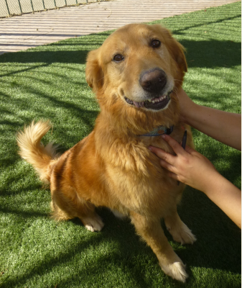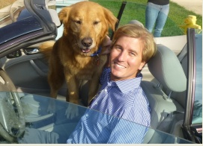

Crossing the Bridge – Gone but Never Forgotten

- Manny
- Sugar Pop
- Charlie Gale
- Sooner
- Kalen aka Bear Bear
- Riley
- Sandia
- Gonzo
- Balto
- Jagger
- Prince
- Charlie aka Chuckie
- Brinkley

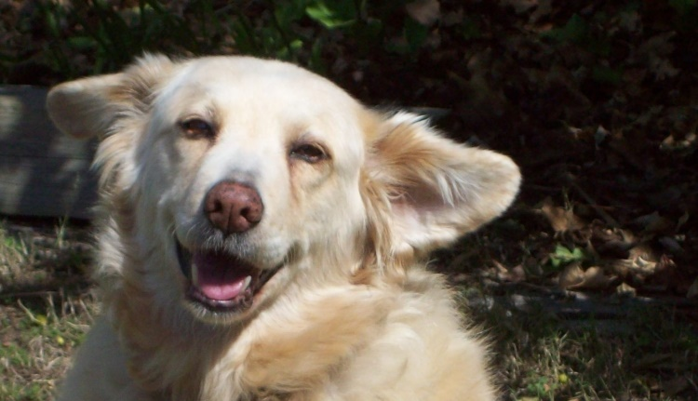
Sandia
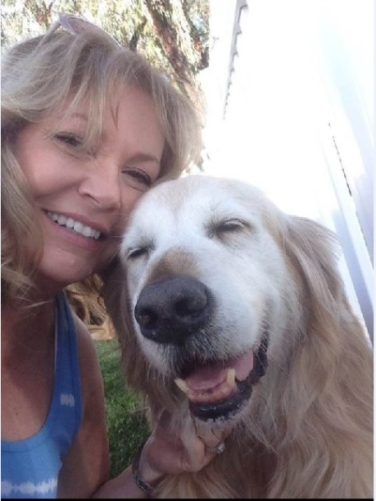
Manny
SCGRR Board of Directors

- Barbara Gale – Founder/Treasurer
- Jenni Morita – Secretary and President Emeritus
- Karyn King – President
- Carrie Madrid – Volunteer Coordinator
- Sharon Morris – Media Chairperson

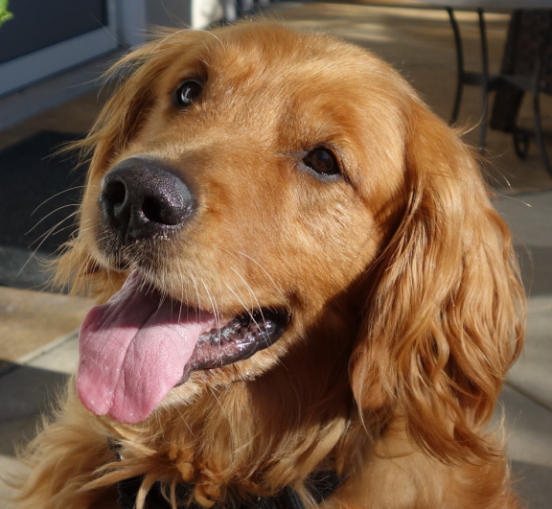

Our Mission and Our Vision
Our mission is to find loving, lifetime homes for all Southern California Golden Retrievers in need, regardless of conditions or circumstances.
We will always strive to heal the sick and injured, rehabilitate the neglected and abused, and nurture the aged and unwanted until we find the perfect family who will shower them with unconditional love.
Our vision is to build a refuge – a sanctuary – to serve as a halfway house where each of our beloved Goldens can rest and recuperate, prior to being placed with a foster or permanent family and moving on in their new lives.

Volunteer Opportunities

We need YOU! Some of the areas where you can give back and help save these beautiful souls include:

Become a Monthly Donor – just go to our website at www.scgrrescue.org and find out how! Every little bit helps.
In Home Interviews – Just an hour or two and week will make a difference.
Fostering – The heart of what we do. Our dogs need a soft spot to land. Especially needed are foster homes with no other dogs for the pups coming in that need to be an “Only Dog”
Transporting Dogs – We have a special team that helps get the dogs from the vet to the foster home or the shelter to the vet.
Events – At least once a month we try and coordinate an event to raise awareness and money. Bring your dog and meet other volunteers as well as the public
Monitoring the Shelters – Volunteers monitor the shelters and the shelter websites to identify a Golden that may need our help
Public Relations/Marketing and Media – Helping with our Newsletter, Flyers, Social Media and other Advertising
