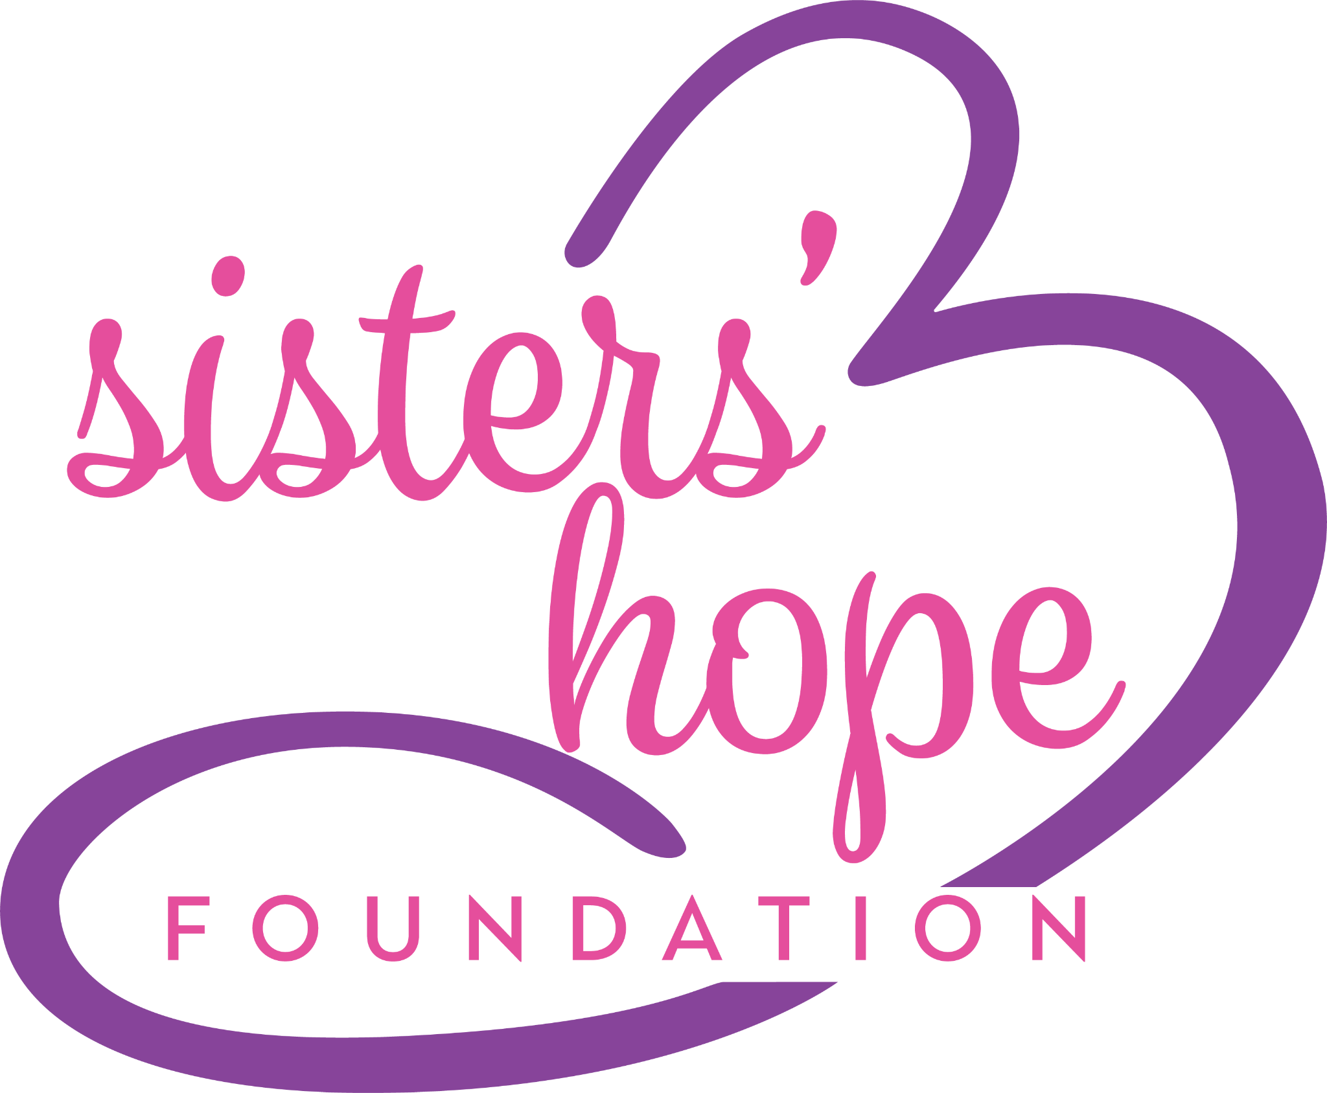 Sisters’ Hope Foundation
2024 Strategic Overview (Education & Outreach)

Executive Summary: Our goal in 2024 is to engage our community and expand our connections through educational sessions and networking.We will highlight the latest research, genetic testing programs, and needs of the ALSP community while providing the newest information and improving knowledge of ALSP within the patient and medical community.

Building off of our existing pillars of Support, Awareness and Cure we will identify more patients by educating the medical community on symptoms and the need to offer genetic testing; we will create an environment where no family faces this diagnosis alone and never hears, “We don’t treat ALSP.” “We have never heard of this disease.” Instead hears, “Let me introduce you to the members of your care team.” and “Let’s discuss the best treatment options for you.”

Mission Statement: The mission of Sisters’ Hope Foundation is to support and empower families impacted by ALSP by:
- educating the public to increase awareness around this rare disease
- advocating for further research and funding to improve treatment options
- connecting patients and families with this diagnosis to build community and support
- providing financial assistance and resources to those in need

Vision Statement: Through Sisters’ Hope Foundation, we envision a world where those affected by ALSP have support and knowledge, leading to a better quality of life and one day, the first survivor of ALSP.

Values:

Honesty & Transparency | Accessibility
Patience | Courage

Never lose focus of the most important GOAL: To Cure ALSP! By continuing to work with industry partners, providing support to patients and their families, raising awareness and educating the global community of clinicians who treat ALSP patients, we will, one day, see the first survivor of ALSP and have a cure for this devastating disease.

2024 Strategic Priorities

Strategic Focus Area and Goal #1: Patients
Advance patient and family awareness of ALSP, by expanding our national and global reach.

Create public awareness of ALSP on a global scale. Disseminate educational materials throughout professional and community networks around the globe by educating patients and their families and allowing them to bring awareness to their network of clinicians/researchers. We will continue to include all patients and their families from around the world and assess the needs of the global patient community.

Strategy 1.1: Global Foundation. Bringing together families around the world who are living with ALSP or caring for someone with ALSP, to connect as a global community.

Strategy 1.2: Gain greater public awareness of the nature and prevalence of ALSP. Work directly with patients and family members to gather insight.

Strategy 1.3: Faces of ALSP. Launch Faces of ALSP, a patient focused initiative and create a Person’s with ALSP Advisory Council.

Strategy 1.4: Documentary. Creation of the SHF 2nd documentary utilizing the FDA Patient Listening Session presentation.

Strategy 1.5: Visual media and materials. Expand visual media including handouts, brochures, infographics to increase awareness of ALSP. Creation and development of education and awareness materials to be disseminated around the globe.

Strategy 1.6: Partnerships. Partner with rare disease organizations, form new partnerships and utilize partnerships with rare disease alliances (NORD, Global Genes)

Strategy 1.7: Marketing and Webinar Initiatives. Continue social media marketing campaign to educate and raise awareness including key marketing initiatives surrounding genetic testing and patient stories.

Strategy 1.8: Genetic Testing. Promote the importance of genetic testing in families.Utilize Genetic Counselor from Orphan Disease Center - Jump Start Program to expand CSF1R on genetic testing panels

Strategy 1.9: ALSP Community. Enabling our community to advocate for and drive change. Empower volunteers to educate clinicians/researchers and professional educators in their local communities. Empower our community through advocacy campaigns, speaking engagements, and other volunteer programs.

Strategy 1.10: Support Groups. Increase participation in support group meetings for patients and caregivers.Increase engagement in the private FB group by posting surveys, questions, topics.

Strategic Focus Area and Goal #2: Clinicians/Researchers
Educate the medical community to ensure that high-quality, responsive ALSP care and support are available to better serve patients and families, at every stage of this journey.

SHF partners with Key Opinion Leaders and their institutions, local neurologists and clinicians who are a part of the ALSP care team, to develop multiple avenues for professional education, equipping clinicians with the knowledge and skills to serve patients and families. Enabling healthcare professionals to become more knowledgeable about ALSP, better able to diagnose and provide quality medical support.

Patients and families affected by ALSP often gain knowledge of this disease through great struggle and at great personal cost. Fostering widespread awareness of this disease is the first step to address this challenge

Strategy 2.1: Education Departments. Connect with education departments at local hospitals, academic institutions and Centers of Excellence to include ALSP education into their training and curriculum.

Strategy 2.2: Visual Media/Content Creation. Establish SHF as the ALSP central information source for training/knowledge of health care professionals.

Strategy 2.3: MSAC. Expand and ensure stronger inclusion of multidisciplinary ALSP care experts in the Medical & Scientific Advisory Council.

Strategy 2.4: Clinician Education. Shorten the time to diagnosis and decrease the misdiagnosis rate by providing access to publications and materials that help clinicians provide an accurate diagnosis in a shorter amount of time. “You can’t diagnose a patient with a disease you do not know exists.”

Strategy 2.5: Expand Clinician Database. Increase the number of clinicians who recognize ALSP as a neurodegenerative disease and are able to accurately diagnose by creating a robust clinician network so there are no geographical gaps.

Strategy 2.5: Talk to an Expert. Implement “Talk to an Expert” for patients and families who are interested in a private one-on-one consultation with expert physicians, Nurse Practitioners, Physician Assistants and/or Counselors.

Strategic Focus Area and Goal #3: Projects
Expanding our reach by utilizing existing programs to enable and support community growth and by adding new programs.

Strategy 3.1: Fundraisers. Increase patient and community led fundraisers by sharing an online toolkit and encouraging the community to lead the fundraising initiatives.

Strategy 3.2: Natural History Studies. Continue to promote and educate about current Natural History Studies.

Strategy 3.3: Underserved communities. Expand our conversation about ALSP with underserved communities including young adult caregivers and families with children and teens.

Strategy 3.4: Ambassador Programs. Advance awareness and expand national and global reach by expanding our 3 ambassador programs. By including ambassadors we can define and disseminate materials and initiatives at a more personal level to our community. Global Ambassadors, Family Ambassadors and Youth Ambassadors

Strategy 3.5: Education and Resources available from other Patient Advocacy Groups. Utilize existing resources from larger, established organizations. (Everylife Foundation, NORD, Global Genes, ULF, Alex TLC, Hunters Hope, ELA, EURORDIS).

Strategy 3.6: Events, Meetings, Conferences. Attend and network at conferences. Provide 2 ALSP focused conferences: 2nd Annual Regenerative Medicine Conference: in partnership with Novoglia, CIRM and UCI. (Irvine, CA) and ULF Break-out session focused on ALSP (Itasca, IL)

Strategy 3.7: Hope Fund. Our priorities will always put patients 1st. That’s why we created the Hope Fund. Expand the newly created fund by encouraging donors to donate specifically to the fund. Money to be used to provide financial assistance to families struggling to pay for care supplies, co-pays, medical bills, basic necessities.

Strategy 3.8: Legislative Initiatives/Regulatory Affairs. Work closely with the Everylife Foundation, members of congress and state legislatures to increase awareness and advocate for change. Work with state representatives to designate May as ALSP Awareness Month in each state. Pursue compassionate allowance designation for ALSP.

Strategy 3.9: SHF and ALSP Across America. ALSP on the Road, providing community outreach, awareness and education. Introduce the SHF Mobile van to act as a moving billboard with a pop-up shop (Q4). Pop-up shop to include SHF related swag, brain related items.

Strategy 3.10: FDA Patient-Led Listening Sessions. Present to the FDA on January 17, 2024.

Strategy 3.11: New Tools and Technology: Patient/Clinician portal, patient registry, CRM, fundraising platform, website.

Strategy 3.12: Podcast and Blog. Increase our reach and raise awareness by utilizing new platforms.

