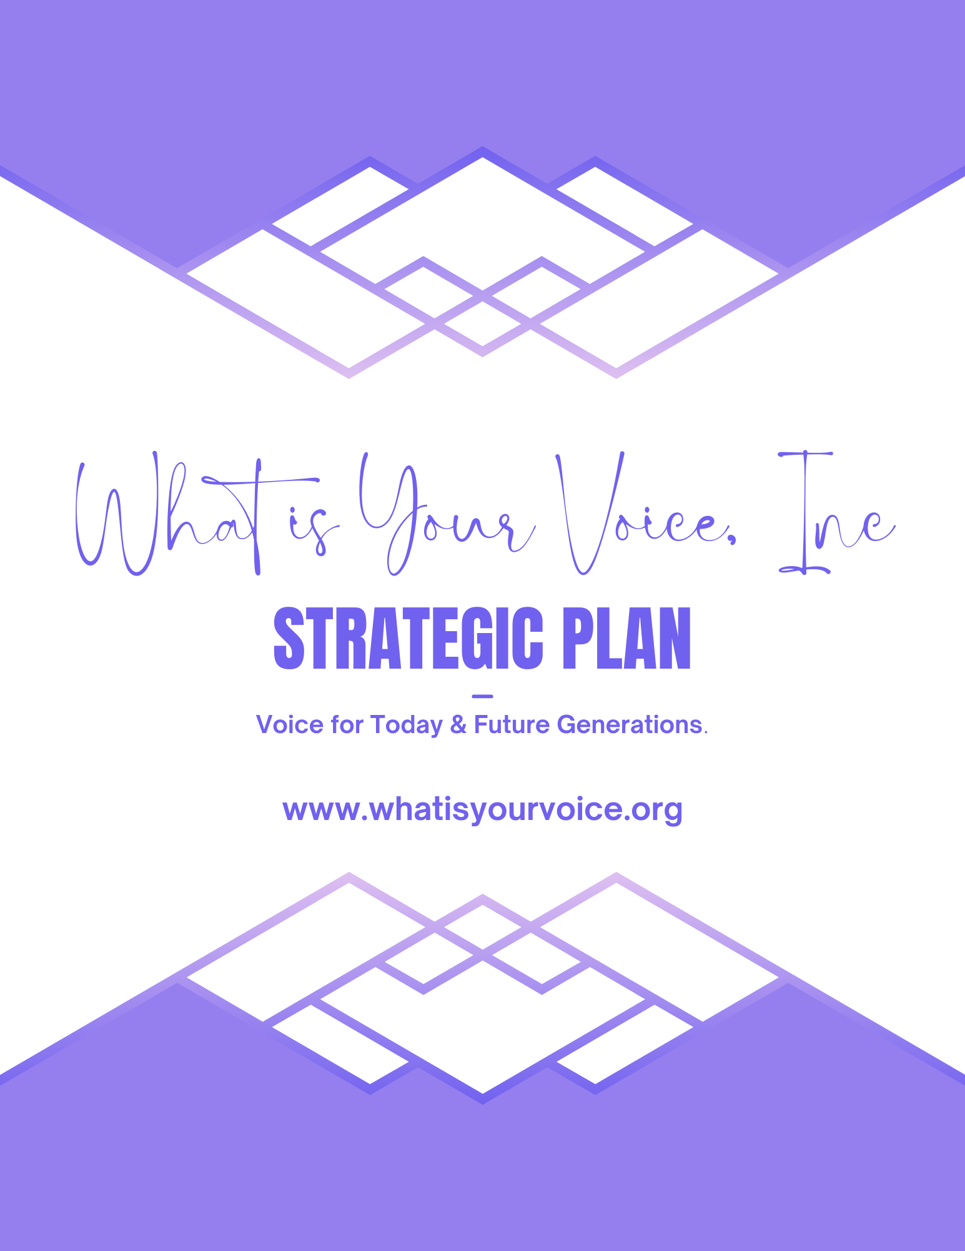

MISSION
Mission Clarity | Marketing and Public Relations | Financial  Stability | Community Engagement | Infrastructure  & Process
GOAL: To Identify and articulate a clear, consistent and defining message around who What is Your Voice is and What is Your Voice does to make a difference in our community. | GOAL: To create a coordinated a consistent strategy around communicating What is Your Voice’s  Message to the community  while building relationships and partnerships to advance the mission. | GOAL: To keep What is Your Voice viable while allowing the board, staff, and community to fulfill the mission of What is Your Voice. | GOAL: To raise awareness within the community about the essential factors to the What is Your Voice mission of educating, advocating and empowering. | GOAL: To implement our strategic vision, improve the delivery of our mission and ensure a sustainable organization.
Key Action  Steps | Key Action  Steps | Key Action Steps | Key Action  Steps | Key Action  Steps
#1. Enhance or affirm purpose statement and core values.  #2. Assess programs to ensure alignment with mission, vision, purpose and core values.  #3. Create a mission “Elevator Speech” for the Board, Staff & Volunteers. | #1. Create a comprehensive and professional Marketing strategic Plan.  #2. Evaluate existing partnerships to ensure they are mission-driven and value producing; consider eliminating some or adding new ones if warranted. | #1.Create a comprehensive and professional Fundraising Strategic Plan.  Fundraising plan to include assessments of current revenue model, new “best practices”  Opportunities, staff/board deployment, and an enhanced stewardship plan.  #2. Create a Case for Support. | #1. Assess current volunteer program against priority needs; leverage specific talents; consider a “Speakers Bureau” or similar trained volunteer model.  #2. Engage with as many relevant community constituencies as possible; participate in other organization’s events and activities. | #1. Evaluate and align staff time/resources/position descriptions with strategic needs.  #2. Evaluate Board position descriptions and expertise/gaps.  #3. Evaluate buildings and grounds to identify maintenance needs.  #4. Monitor and engage in national industry trends an best practices.

