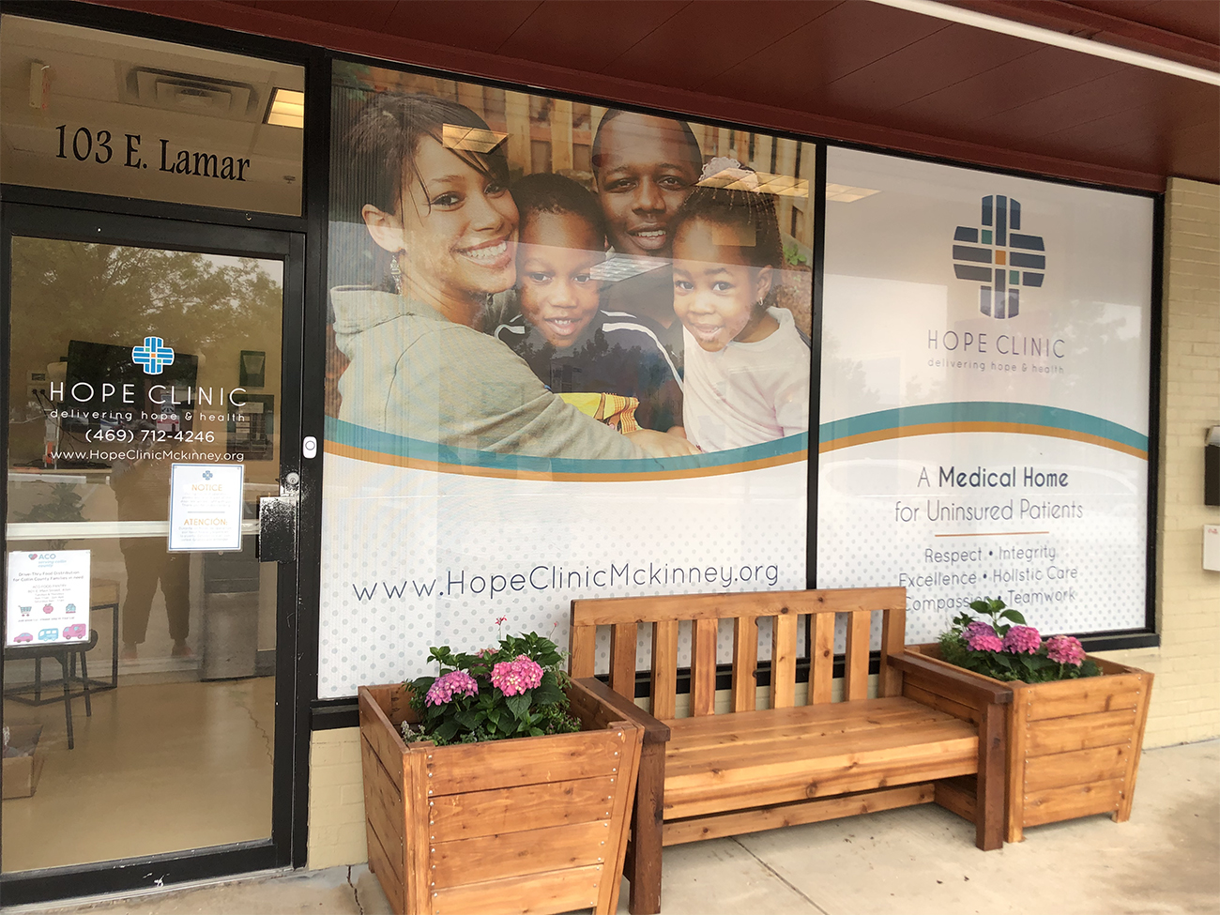

Hope Clinic of McKinney
A STRATEGIC PLAN
for Moving Forward
2020-2023
the carolchildress group
Rockwall, TX
May 29, 2020

History of Hope Clinic McKinney
Hope Clinic of McKinney is a medical, vision, and behavioral health clinic that serves the uninsured and under-resourced residents of McKinney, TX.
In 2014, faith based and community leaders in McKinney began to recognize the unmet need for quality care for the uninsured in their community. 12% of McKinney residents were without medical insurance and in East McKinney, where Hope Clinic would eventually be located, the need was even higher.
In June, 2016 led by leadership from The Parks Church, a team of volunteers and partners was formed to bring the idea and dream of a nonprofit medical clinic to provide healing and hope in McKinney into reality. Hope Clinic of Garland, a well-established charitable clinic in Dallas County, welcomed the team into their facility and provided much-needed encouragement and knowledge.
Early initiatives of Hope Clinic included a partnership with the Baptist Immigration Center, who generously offered to donate the use of their building when they were closed. The Empowering Community Health Outreach donated their consulting services to provide vital direction and infrastructure to clinic planning.
Through the hard work of its volunteers and with the support of the community, Hope Clinic of McKinney saw its first patient and began operations one day a week at the Baptist Immigration Center in July, 2017 to provide medical services regardless of a patient’s ability to pay.
By 2018, clinic operations expanded to two days and in September, 2019 Hope Clinic relocated to its current location at 103 E. Lamar which is dedicated permanent clinic space. This new space allowed for increased operating hours and service to more patients.
Hope Clinic of McKinney is committed to sharing the love of Christ by providing hope and healing for the whole person and becoming the full time medical home for over 1,000 uninsured residents in McKinney. Through its staff and more than 100 volunteers, it strives to create a space where everyone is treated 2 with dignity, respect and love while delivering high quality medical, wellness and spiritual care.

Mission
The mission of Hope Clinic is to share the love of Christ by partnering with our community to provide quality, compassionate health care to our medically underserved neighbors.
Vision
The vision of Hope Clinic is that all McKinney residents will have access to quality, affordable medical care.
Values
As a faith based clinic, Hope Clinic exhibits Christian values including:
- Dignity and Respect: Every person who walks through our doors has innate value because they were created in the image of God. We love our patients because Christ loved them first.
- Integrity: We do what we say we are going to do. We take responsibility for our actions, maintain a growth mindset, admit our mistakes and learn from them. We do the right thing for the right reason, even when it isn’t the easiest thing.
- Excellence: We deliver excellent health care and maintain our professionalism. We do everything thoughtfully and to the best of our ability. We plan as best we can and take timely actions using available information. We are not afraid to change course as other information becomes available.
- Holistic Care: We treat the whole human, not just the medical issue.
- Compassion: We are relational, not transactional, for that is where true community development begins.
- Teamwork: We are all on the same team, and treat each other as such. We give each other the benefit of the doubt. We step up when we see a need. We know that together we can accomplish more than we can alone.

PRESENT LEADERSHIP OF HOPE CLINIC MCKINNEY
Hope Clinic McKinney is governed by a nine member Board of Directors comprised faith based leaders, healthcare professionals, and other community and area leadership in accordance with their adopted by-laws.
Hope Clinic McKinney is an IRS approved 501 (c) 3 nonprofit organization.
Board of Directors
Kyle Redel, President
Stephen Twyman, MD, MPH,
Clinical Physician and Medical Director
Billy Booker
Teresa Craighead
Sam DeFord
Sean Howe
Pat Reilly, CPA
Aaron Snell
Jenny Williams
Executive Director Melissa Willmarth, CPA

CREATION OF THIS STRATEGIC PLAN
The Hope Clinic Board of Directors and Executive Director met May 20 in a four hour strategic planning session facilitated by Carol Childress, founder of the carolchildress group, a consulting practice that helps leaders and organizations understand today and lead for tomorrow.
They identified fourteen key issues and concerns, reduced the list to their six 4 most important issues and then prioritized the six issues. The remainder of the session was devoted to a discussion of these six strategic objectives to be addressed as Hope Clinic moves forward over the next three years.
HOPE CLINIC MCKINNEY STRATEGIC OBJECTIVES 2020-2023

Strategic Objective One
Recruit and Enlist a Full Time Clinic Physician and Medical Director
- The ideal candidate would be someone who can serve as both the Clinic Physician and the Medical Director.
- The goal is to begin the recruitment process by June 1 and to have he/she be able to begin employment at the beginning of Q3/2020, preferably in October, to allow for orientation by Dr. Stephen Twyman before he leaves the staff of Hope Clinic McKinney to serve overseas.
- Create a job description for a full time Clinic Physician / Medical Director that will include desired qualifications, duties, responsibilities and expectations, a salary and benefits package and other essential information related to the missions, vision, values , governance, staff and internal culture of Hope Clinic McKinney.
- Create a recruitment plan that would identify critical posting opportunities, with appropriate professional medical societies, nonprofit clinic associations, journals and publications, area hospitals and other healthcare associations, and appropriate healthcare partnerships and networks.

Strategic Objective Two
Achieve Financial Sustainability for Future Expansion of Clinic Services,
Staff, and Space
- The two assumptions related to this objective are:
• 40 hour per week availability for services to clinic patients
• Provider patient panel: 1,200 – 1,500 patients per year
• Necessary additional information needed will include:
- a clear understanding and graphics (pie or bar charts) related to the sources of average nonprofit clinic support and also specifically Hope Clinic McKinney support
- Current budget allocations and funded staff positions
• Diversify Hope Clinic's Donor/Support Base
- Increase the diversity of the Hope Clinic Board related to gender and ethnicity to be more reflective of the target client population served.
- Increase the support of the clinic by other churches and faith based organizations.
- Increase support and sponsorship by the area business community.
- Increase the level of support by individual donors.
- Increase the support via grants from foundations and other potential funding organizations including governments and nonprofits.
- Increase the support from medical entities such as hospitals, medical and professional groups.
- Increase the number and amount of In-Kind contributions made to the clinic.
- One source would be to get the lab costs of the clinic donated via an In Kind agreement.
- Continue and expand the current monthly donor program, Hope Heroes.
- Expand the annual fund raiser, Hope Rising.
- Actively participate in the North Texas Giving Day.
Strategic Objective Three
Enhance the Governance Capacity and Practices of the Hope Clinic Board as a Nonprofit Fiduciary and Advisory Board and the Hope Clinic Staff
- Maintain the core values of Hope Clinic.
- Create a document that clearly identifies both the qualifications for service on the Hope Clinic Board of Directors and the expectations and responsibilities of Board membership.
- Create a well-defined interview process for potential new board members.
- Create an orientation process for new board members.
- Integrate into each Board meeting a brief time of education / learning concerning board governance and best practices.
- Provide continuing education opportunities for appropriate Hope Clinic staff at regional, state and national conferences related to nonprofit medical clinics.

Strategic Objective Four
Strengthen Existing and Create New Partnerships and Collaborations
- Continue participation in the Collin County Coalition of Charitable Clinics.
- Baylor Scott & White and Texas Health Resources
- Relationships
- Quality direction
- Budget
- Shared resources
- Federally Qualified Health Centers (FQHC) in Collin County
- Community Health Clinic of McKinney
- Other social service organizations and coalitions in Collin County
- Other faith based communities
- Dallas Women's Foundation
- Area Nursing Schools
- TWU, Baylor, UT Arlington, TCU, Tarrant County College, Collin County, Brookhaven College, El Centro College, Mountain View College, Concorde Career Institute, Southwestern Adventist University, West Coast University, Dallas Nursing Institute, Fortis Institute, and Carrington College.
- Area Medical Schools
- UT Southwestern, University of North Texas Health Science Center, Texas A&M Medical School Regional Campus in Dallas
Strategic Objective Five
Create a Full Time Director of Development Staff Position
To Be Operational by Summer, 2021
- Major responsibilities of the Director of Development would include:
- Grant writing
- Marketing
- Social Media
- Website
- Create and cultivate relationships with Foundations
- Create and cultivate relationships with area Churches
- Along with the Executive Director, serve as an advocate for Hope Clinic in the community
- Mobilize volunteers
Strategic Objective Six
Capture and Communicate the Impact of Hope Clinic on the Community
- Create a Dashboard of critical metrics.
- Determine the value of health care services provided by Hope Clinic McKinney.
- Create a process of spiritual assessment for clinic patients and a tracking system to measure the spiritual impact of their engagement with Hope Clinic McKinney.
- Increase the number of male pastoral care volunteers.

THIS IS THE FIRST STEP...
The identification of the six strategic objectives is a very important first step in the implementation of the strategic plan but much work remains.
The objectives serve as the major "markers" and leverage points on the journey to the future.
Each of the six strategic objectives will need to be expanded with detailed next steps, additional research, time frame and schedule, assigned responsibilities, work teams of the board, and cultivation of relationships necessary to fully implement the plan.

