**The Education Trust**

**Strategic Plan Overview — SPRING 2018**

|  |  |
| --- | --- |
| **OVERARCHING STRATEGIC FRAMEWORK** | |
| **MISSION** | The Education Trust is a nonprofit organization that promotes closing opportunity gaps by expanding excellence and equity in education for students of color and those from low-income families from pre-kindergarten through college. Through research and advocacy, the organization builds and engages diverse communities that care about education equity, increases political and public will to act on equity issues, and increases college access and completion for historically underserved students. |
| **THE WAY**  **WE WORK** | * We work alongside educators, parents, students, policymakers, and civic and business leaders in communities across the country, providing practical assistance in their efforts to transform schools and colleges into institutions that serve all students well. * We analyze local, state, and national data and use what we learn to help build broader understanding of achievement and opportunity gaps and deeper commitment to the actions necessary to close them. * We actively work to shape national and state policy, bringing lessons learned from on-the-ground work and from unflinching data analyses to build the case for policies that will help all students reach high levels of achievement. |
| **GOALS** | * Broaden public demand for improved results in P-12 and higher education, including building and strengthening coalitions. * Advocate for the adoption of needed changes in policy and practice at the federal, state, and institutional levels. * Ensure that the Education Trust has the strategic leadership, direction, infrastructure, and resources to maintain and grow — its position as a credible, vital, and sustainable organization. |
| **CURRENT TOP PRIORITIES** | 1. Cultivate and engage partnerships for action to improve outcomes for low-income students and students of color. 2. Redefine and amplify c*ollege student* success in ways that prioritize low income students and students of color through research, policy, and practice. 3. Advocate for equitable policy and practice that advance college- and career-readiness for all students, particularly low-income students and students of color. 4. Strengthen and support the leadership, infrastructure, resources, and culture required to be a credible voice on equity issues for low income students and students of color. |

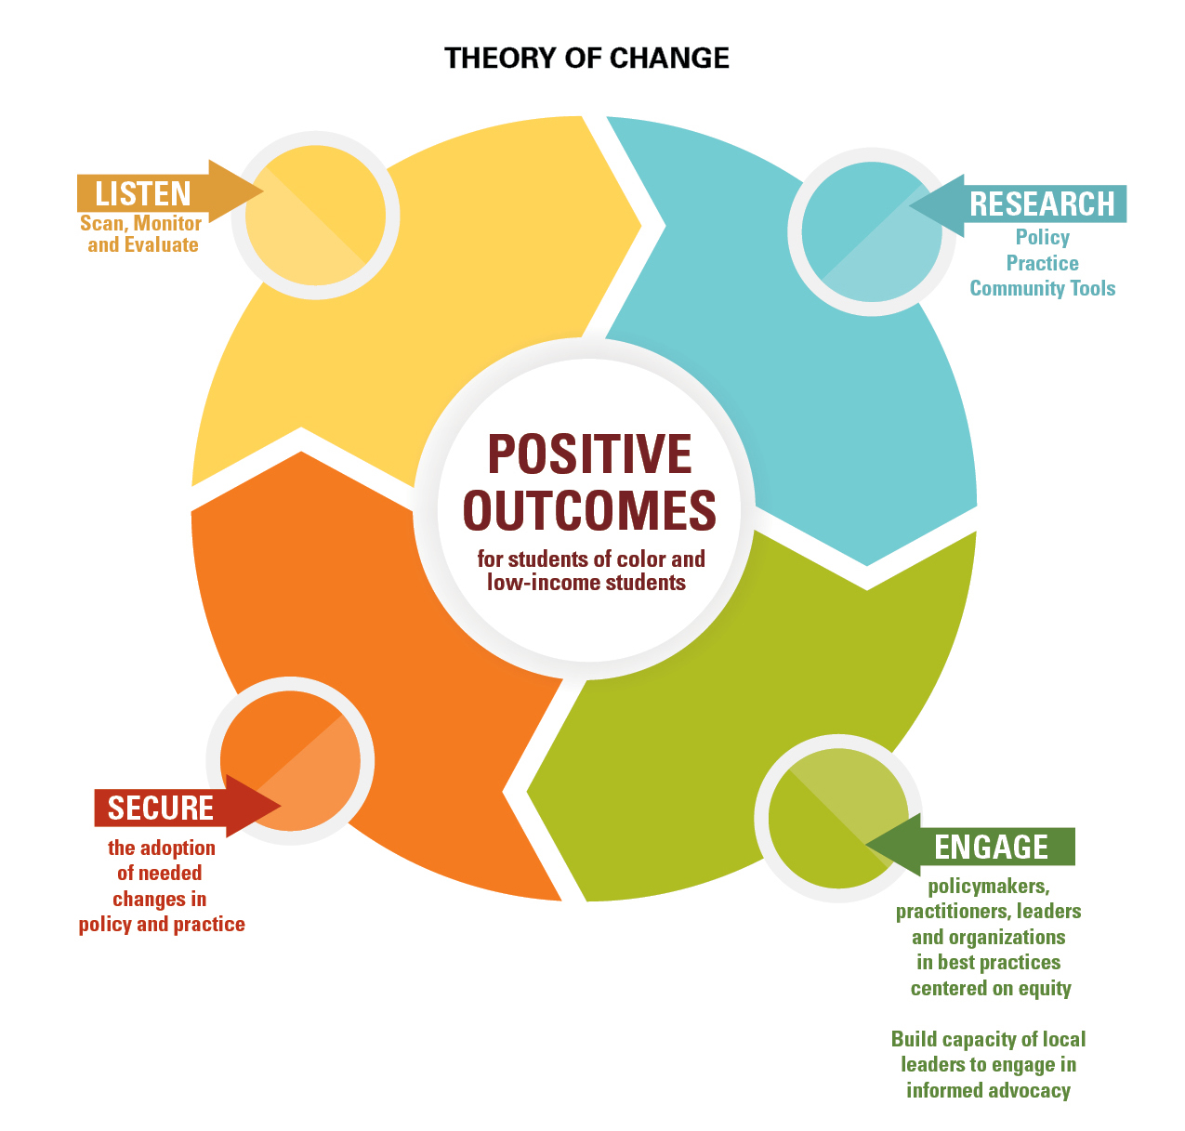

**The Current Landscape**

* The agency to demand that key education decisions prioritize the needs, interests, and potential of low-income students and students of color rests largely with advocates representing the communities with the most at stake in these decisions: civil rights and social justice advocates, business leaders, parents and families, and equity-minded educators.
* The need for strong, effective equity advocacy is all the more urgent in light of the current political climate, in which federal leaders have shown themselves to be at best indifferent—and far too often hostile—to the interests of historically underserved communities.
* So we’ve joined our national partners in the business, civil rights, immigrant rights, disability rights, educator, parent, and education reform communities and raised our collective voices when vulnerable students are at risk: from the President ending DACA to Secretary DeVos approving state ESSA plans than undermine hard-won equity guardrails in the law to an Administration budget proposal that was nothing short of an assault on the American Dream. And we’ve seen some success. For example, contrary to the devastating cuts the Administration proposed, the most recent federal budget actually increases the maximum Pell Grant, and holds funding for educator development steady. This tells us that even in these trying times, progress is possible.
* And we’re continuing to devote significant energy and effort where we see the biggest possibility for equity-advancing action: the states. We’re expanding our work of supporting and engaging diverse state equity coalitions, providing technical assistance to more developed coalitions and providing on-the-ground support and resources to more nascent ones.
* This deeper state engagement began around ESSA implementation, and we continue to support coalitions in this critical work, with a particular focus on school improvement. We’ve also begun to expand the range of equity-advancing issues we support coalitions on to include, among others, resource equity, teacher diversity and equitable access to effective teachers, access to high-quality early childhood education, access to and success in rigorous coursework, and postsecondary access, affordability, innovation, and completion.

**Top Priorities**

**Priority One: Cultivate and engage partnerships for action to improve outcomes for low-income students and students of color.**

* Provide policy and advocacy support to state and local advocacy organizations on a range of equity-advancing issues, including ESSA implementation, resource equity, teacher diversity and equitable access to effective teachers, evidenced based school improvement, access to high-quality early childhood education, access to and success in rigorous coursework, and postsecondary access, affordability, innovation, and completion.
* Strengthen Ed Trust support to state equity coalitions, including through pass-through support and on-the-ground Ed Trust presence, as appropriate per state. In addition, expand the membership of these coalitions to include families and equity-focused educators.
* Continue work with national business, civil rights, disability rights, immigrants’ rights, student, family, equity-minded educator, and education reform organizations to share information, strategize, and, where appropriate, take collective action on P-12 federal policy issues, including ESSA implementation and the budget.
* Continue to work with diverse partners to protect and strengthen the Pell Grant program in the federal budget, and to lay the groundwork for equity-advancing access, affordability, evidence-based innovation, and completion policies in HEA reauthorization including higher education and state and federal support for education among undocumented and justice-impacted youth and adults.

* Identify, expand partnerships with, and build capacity among national, state, and campus organizations of students to tell their stories and advocate for education equity policies.

**FY19 Milestones**

* Expand our on-the-ground presence aimed at supporting and growing state equity coalitions in at least three states through a combination of pass-through support to lead partner organizations and direct staffing.  — Fall 2018
* Provide diverse P-12 and higher education equity coalitions in at least six states with targeted policy and advocacy support on equity-advancing issues to equip each coalition to take concrete advocacy actions (i.e. publishing policy briefs, submitting policy recommendations, testifying before policymakers, convening stakeholders, publishing op-eds, launching digital campaigns, etc.) – Spring 2019
* Pilot a parent equity fellowship in at least 4 states to develop the advocacy capacity of parent leaders and facilitate their participation in state equity coalitions. – Summer 2019
* Work alongside national partners to advance federal budget priorities, including Pell and Title II– FY19
* Work alongside diverse advocacy partners to generate and disseminate at least 5 pieces of advocacy collateral on HEA reauthorization/federal policy on postsecondary access, affordability, and innovation, and completion— Summer 2019
* Amplify and engage more student voices and non-traditional advocates (families, community members and leaders, those outside education field, etc.) -- Summer 2019
* In collaboration with our state-level partners, communications team serves as consultant to advocates and partners in states identified for DSE work -- Summer 2019

**Priority Two: Redefine and amplify *college student* success in ways that prioritize low income students and students of color through research, policy, and practice.**

* Analyze and broadly report key trends on access, affordability, and completion for low-income students and students of color, highlighting good and bad institutional actors focusing on the importance of institutional practice
* Continue refining College Results Online to include newly available data, while also building out a new “equity report card” to publicly grade colleges and universities on their service to low-income students and students of color.
* Expand College Results Online to include a peer comparison tool for community colleges.
* Build out new state “equity report card” to publicly grade states on their service to low-income students and students of color with a focus on access, affordability and completion.
* Using these new tools, work with the media, as well as new and existing advocacy partners, to bring positive attention to states and institutions that serve low-income students and students of color well, and to increase pressure on those that don’t.
* Through strategic publishing and collaboration, Ed Trust will build demand for institutional change among broad audiences and build capacity among partner organizations and associations engaged in institutional practice work to do that work with an equity lens.
* Through publishing and partnership activities we aim to highlight evidence of promising practices that can advance equity, galvanize a movement for dramatic improvement in higher education, and equip institutional change organizations to scale practices that improve opportunity and outcomes for low-income students and students of color at institutions across the country.
* Identify and hold up states doing a better job than others in adopting policies that incentivize college access and success for low-income students and students of color — while cultivating strong equity champions and building coalitions to press for policy change.

**FY19 Milestones**

* Convene Federal Equity Roundtables-Fall 2018; Spring 2019
* Publish brief on Equity Analysis of Outcomes Based Funding Policies-Fall 2018
* Publish principles on Equity Focused Accountability-Fall 2018
* Hold State Higher Education Equity Bootcamp for Higher Education Deeper State Engagement states -Fall 2018
* Conduct Quarterly visits to Higher Education Deeper State Engagement states- Summer 2019
* Convene working group on Equity Focused Accountability-Spring 2019
* Publish communications on Key Principles for Developing Equitable Affordability Policies-Spring 2019
* Amplify and engage more student voices and non-traditional advocates (families, community members and leaders, those outside education field, etc.) -- Summer 2019
* Vary publication toolkit to include more tactics to reach more communities where they are (more digital assets, video releases - beyond just reports) – Summer 2019

**Priority Three: Advocate for policies and practices that advance college- and career-readiness for all students, particularly low-income students and students of color.**

* Based on research, data analysis, and observations from practice, identify and bring attention to inequities in opportunity and achievement for low-income students and students of color with a focus on:
  + Patterns and trends in student outcomes;
  + Spending patterns that shortchange schools and districts serving high concentrations of students of color and students from low income families;
  + Over-exposure to inexperienced, out-of-field, and ineffective teachers;
  + Insufficient diversity in the educator workforce;
  + Inequitable access to rigorous coursework and classroom learning experiences;
  + Inequitable exclusionary discipline practices and insufficient student supports; and
  + Inequitable access to high-quality early learning opportunities.
  + Patterns and trends in school segregation.
* Identify promising policies and practices that would help to ameliorate those inequities if adopted and implemented by state and local policymakers and practitioners.
* Build and support existing coalitions of the on-the-ground advocates and practitioners dedicated to meaningful improvements in policy and practice that will address these inequities, including context-specific versions of the policies and practices identified above.

**FY19 Milestones**

* Publish at least five major communications that call attention to issues of inequitable access and opportunity to educational resources that hinder college- and career-readiness for P through 12 students. — July 2018 – June 2019
* Research, identify, and promote promising policies and practices that advance our eight focus areas and help to eliminate inequities for low- income students and students of color. — July 2018 – June 2019
* Provide direct targeted support to advocates, policymakers and practitioners in Ed Trust’s targeted states that are working to address educational inequities in opportunity and access (including school funding, resource equity, teacher equity, high-quality early learning, and rigorous coursework) for low-income students and students of color. — July 2018 – June 2019
* Amplify and engage more student voices and non-traditional advocates (families, community members and leaders, those outside education field, etc.) -- Summer 2019
* Vary publication toolkit to include more tactics to reach more communities where they are (more digital assets, video releases - beyond just reports) –Summer 2019

**Priority Four:** Strengthen and support the leadership, infrastructure, resources, and culture required to be a credible voice on equity issues for low income students and students of color

* Strategically advance our goals through careful planning, execution, and assessment of our work.
* Implement a board development plan to support organizational leadership.
* Maintain and invest in a diverse staff by providing professional skill development and expanded leadership training.
* Foster a cohesive culture that reflects our values and goals as we continue to build capacity and expand our reach.
* Secure funding from new and existing funders to assure adequate and flexible resources including increased support for deeper state engagement.
* Identify and implement updated operational policies and procedures to support organizational success.

**FY19 Milestones**:

* Recruit at least three new board members based on needs identified in board development plan. — Fall 2018
* Develop framework and implement strategies to provide access to professional development for all staff. — June 2018 – June 2019
* Grow the capacity of our development team with at least one new hire to support senior leadership’s efforts to expand our funder base and diversify revenue streams. — Fall 2018
* Evaluate, source, and implement new financial accounting and processes to ensure greater efficiencies and increase operational capacity, with two to three new hires to support organizational growth. — Winter 2018-19
* Ensure that IT structure supports Cloud- based file sharing and other virtual computing needs — Spring 2018
* Review and refresh Strategic Framework aligned with FY20 budget and work plans to advance key initiatives. — Spring 2019
* More directors and junior staff begin to carry Ed Trust messages publicly with a “communities first” focus (everyone owns our narrative) --- Summer 2019

Secure 100 proactive national media hits (inclusive of blogs, op-eds, interviews, etc.) (50% increase over 50 obtained since August 2017) – Summer 2019

* Spokespeople get quoted in more stories where Ed Trust is not the headline, and Ed Trust provides background support for more stories/opportunities on issues that intersect with our work beyond education – Summer 2019
* Third-party validators and influencers continue to lift Ed Trust messages to essential, broader audiences (e.g. students, families, millennials, communities we serve) –Summer 2019